ie Official Publication of ALOA—An International Association of Security Professionals

ikL

* % H .■ 5it

U -w TlMs

% ir’ ■ Via

*x*r .•«

1 Rfe TTfl | vfi

Uj tools,

Diamond Drills... Picks... and Laser Tools... Oh My!

October 2004

[www.aloa.org](http://www.aloa.org)

**From Iraq\***

HLOH Member

Don Shiles Comes Home

**\lsO in this Issue:** The Kaba Mas X Series,  
V Spooky Halloween Special Feature, The latest

****##**********4:**3_£flGlT 303 Breck H. Camp CML PO Box 47070 Atlanta GA 30362-0070

m the ALOA Scholarship Foundation, and More!

I.II

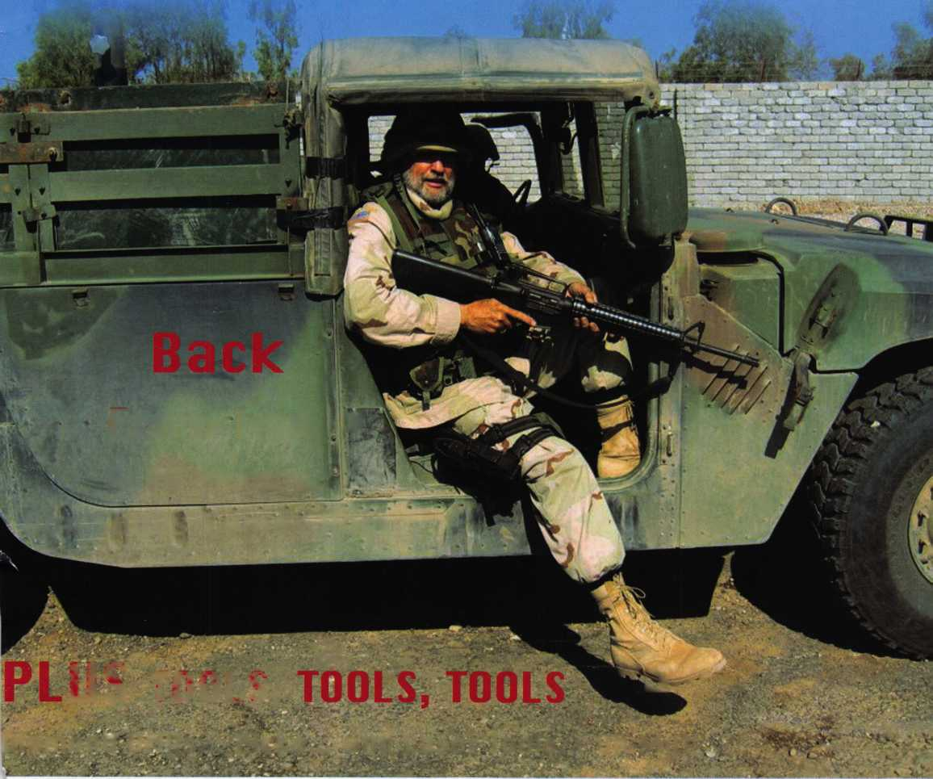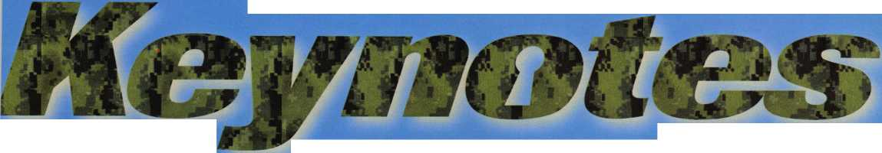

*An American Original*

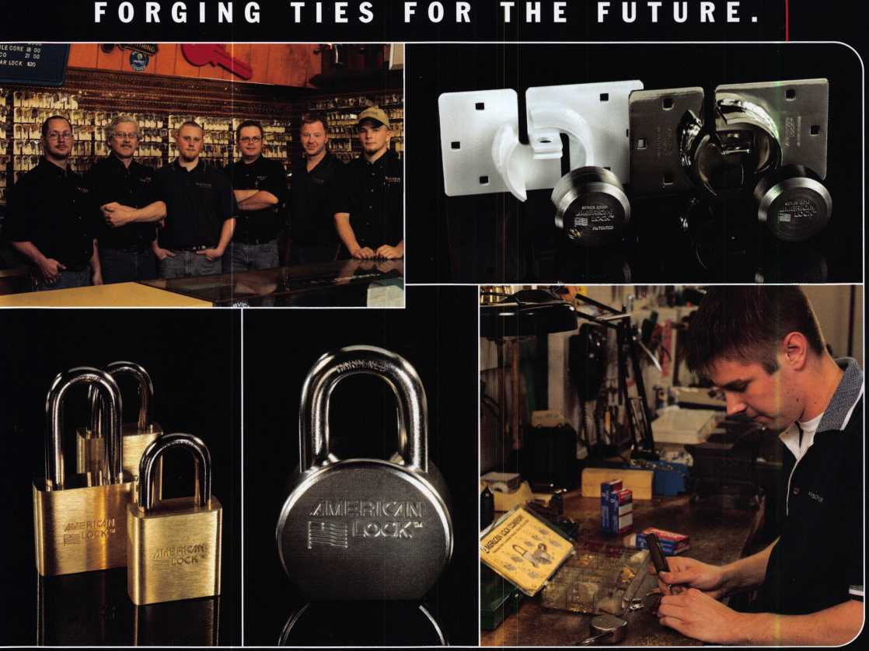

Building on its 90-year tradition of quality, ingenuity and locksmith support, American Lock today delivers your security needs as never before.

Numerous innovations in padlock construction — including solid body locks, double-ball locking mechanisms, serviceable components and high-security cover plates — long ago established American Lock as the industry's security leader.

Unmatched services such as Make-to-Order capability, Lock Express™, key charting, custom marking, locksmith training, merchandising displays and other time­

saving systems help make your life easier, and your operation more profitable.

**The best is yet to come.**

Now American brings renewed vigor to locksmiths everywhere, aided by joining forces with Master Lock during the past year ... with additional resources focused on developing new products and value-added services to further help you grow your business.

Contact your distributor for details as they unfold.

***The Locksmith's Lock***®

© 2004 American Lock Company



The 0afc and Vault Technicians Sssociataion  
donnention and Trade j&hom

March 6—12, 200S

***Hyatt Regency, Lexington KY***

^ Ml VceY Mac, keeping up with the latest the industry has to offer has never been more important for us safe technicians. Let me tell ya, you gotta stay aware of what today's top safe distributors and manufacturers are putting out there. It's crucial to making a humdinger of a purchasing decision, buddy. And another thing, time is of the essence when it comes to education. New things pop up every day, Daddy-O, and that makes top-notch safe classes as good as gold. The only chance to get world-class education and meet with the industry's top distributors and manufacturers is the SAFETECH Convention and Trade Show. Boy, is it swell! SAFETECH 2005 offers you a chance to meet with potential customers and bolster business in ways you never thought possible. Discover the safes of tomorrow! Gee whiz, jump and jive your way into Safetech 2005, and you'll be part of our knock 'em, sock 'em show of all shows!!

*Safetech Oisite Seautifuf Lexington, Kentucky!*

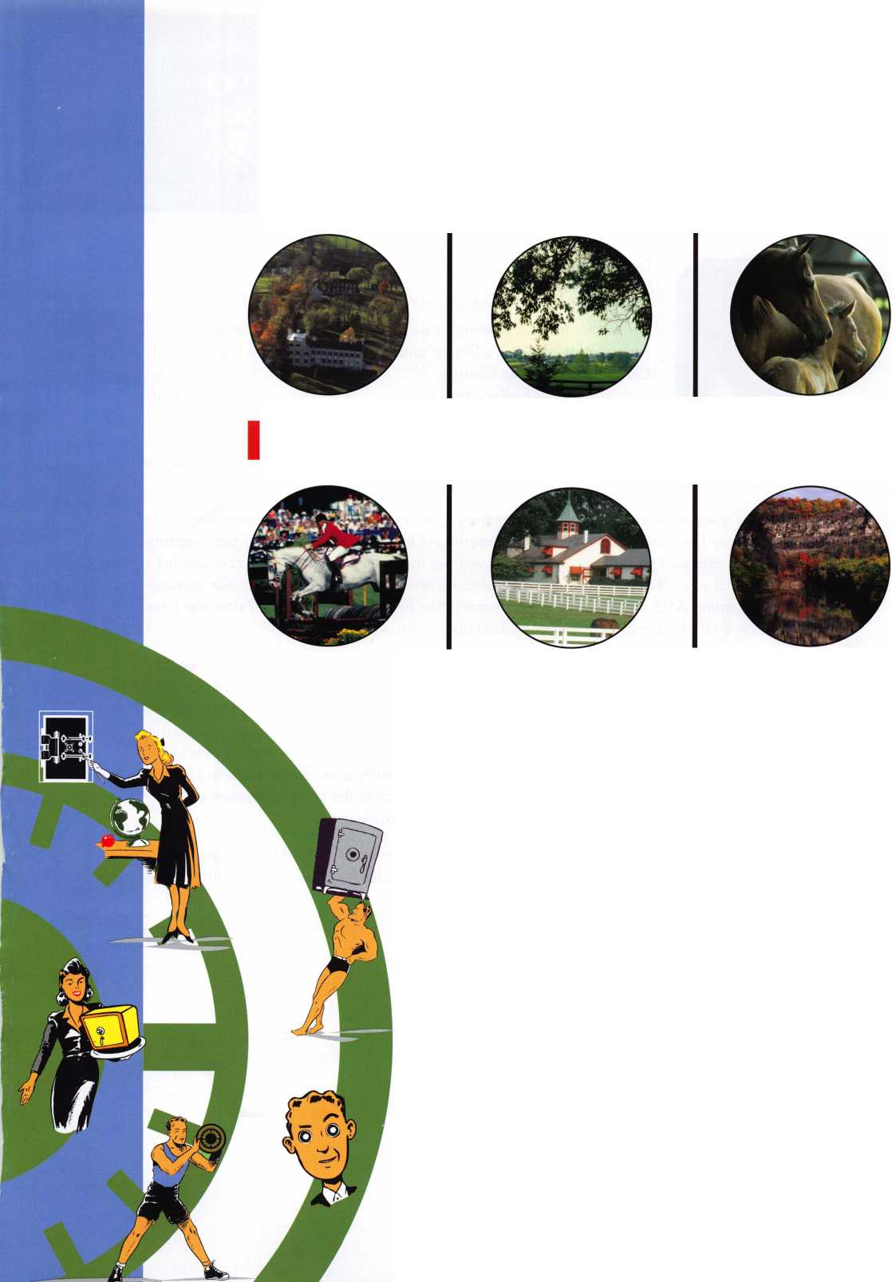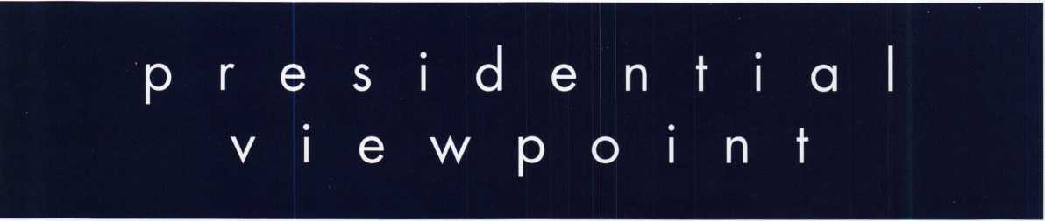

Dear Members,

I would like to share with you a recent experience that that was both

enjoyable and eye opening. I was a guest of Bill Neff's at the Is*  
Annual Past President's Dinner and Golf Outing of ASIS International  
Central Pennsylvania Chapter 79. Bill has served two terms as chair-  
man of that association. Jack Magee of Woodbury, NJ and the chair-  
man of the South Jersey Chapter of ASIS International, was also in  
our foursome. Bill and Jack are both locksmiths and, they have very  
forward-thinking views of the industry! They have seen the need to join

and become actively involved in ASIS. They are also bad golfers!!!!

I am mainly involved with automotive locksmithing and safe work and I have never attended ASIS functions. The thing that I found most interesting is that ASIS is made up of both security professionals and end users! How many of us will see our clients at a locksmith convention? For those of us who deal primarily with commercial clients, we should know that our competi­tors are attending ASIS meetings! This is an association that many of us should consider inter­acting with. And, the people are extremely friendly!

Those who know me best know that I am not a politician. But, since I have a forum, I would like to make a political recommendation. ALOA is very interested in the Association Health Plan. If it is passed, it will be beneficial to this association and it's members. It means that we as an association can offer health care to our members on a national level at rates that very large corporations or groups get. Those of you that read Paul Kanitra's monthly reports know that President Bush is a strong supporter of that plan and health care reform in general. The Bush administration also promotes tax cuts that are beneficial to the small businessman. Just something to keep in mind when you go to the polls in November.

This month's issue deals with tools of the trade. All of us know that locksmiths love gadgets! We love things that make our work easier and more profitable. Read on to see what will ben­efit us in the future!

Sincerely,

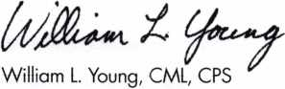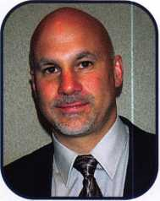

Keynotes • October 2004

a

JM

The HLOR

**Conuention**

**and Security Expo July 17-24, 2005**

SLUEET

Get Ready for RLOR 2005,

a powerful resource to explore innouation and form industry alliances. This year we’ue thouyht of euerything from an exciting location, comfort­able accommodations and a conuention center that is equipped to handle your euery need.

Located just minutes from downtown  
Chicago, Rosemont, Illinois is the  
perfect “business uillage”, designed specifically  
to make your stay conuenient, comfortable  
and aboue all, successful!

The 49th Rnnual RLOR Conuention and Security Expo  
offers top-notch classes, workshops, networking  
opportunities and cutting-edge technology.

Rnd don’t miss out on the fine dining and enter-  
tainment options that Chicago has to offer. Shop  
at the world-famous Magnificent Mile. Eat at  
Morton’s of Chicago or Harry Caray’s Italian  
Restaurant. Uisit the Nauy Pier or catch a ball  
game. The options are endless when you register  
today for the single-most important euent in  
the locksmithing industry.

Baby, you know you want to yo!



**RLOR 2005**

Sweet Home Chicago

**feat**

TOOLS 2004

**10**

**14**

Back from Iraq

Don Shiles is back from a six month tour of duty in Iraq.

A name well recognized for his knowledge as an expert locksmith and a leading authority on lock forensics, his multi-faceted career began in 1955 and has touched countless people, by Claire Cohen, CML

Bread and Butter Picks

The choice of tools required to pick any given lock may vary and the wide array of tools on the market reflect the personal choice and specific training of any given lock­smith. In simple words, we all use what works best for us. Some locksmiths prefer a rake, others a simple hook pick, and many of us have "favorite" tools which seem to work quickly and efficiently on most of the projects we

enCOU nter. Eric Cosfley, CRL

**22**

Trading Information

This month we'll look at two situations found in different trades. This information is critical if you're involved in the installation of floor safes or door hardware.

by Greg Perry, CML, CPS

**24**

Time to Buy Some New Diamonds

This article is primarily a primer on diamond-core drilling with a little information about drilling other hardplates. We'll be using some of the new bits from StrongArm who have redesigned their diamond-core drill to make a great product even better, by Greg Perry CML, CPS

**28**

Kaba Mas X Series

Helpful hints for installing, selling and repairing the Kaba Mas X Series electronic locks" by Jorge R. Carmona III

**30**

The Mystery of the ALOA Apparition

Join us as we investigate mysterious happenings at the  
ALOA Headquarters-A Special holiday feature.

**40**

The ALOA Scholarship Foundation

The Associated Locksmiths of America Scholarship Foundation (ASF) is an important source for educational funding. We support all locksmith efforts to seek educa­tion via technical training and business management from all educational providers.

|  |  |  |  |
| --- | --- | --- | --- |
| u | r | e | s |
| Departments | | | |
| Executive | 5 | Calendar | 8 |
|  |  | Legislative |  |
| Core | 9 | Update | 34 |
|  |  | Classified | 36 |
| Applicants .... | 6 | Associate |  |
|  |  | Members | 38 |

AD INDEX

Keedex 17

Hinge Doctor 19

Security Lock Distributors 21 A&B Safe Corporation 35, 37 Turn 10 36

Lockman Tools 37

Corporate Safe Specialists 41 Professional Business Products 42

Adesco 43

D & D Technologies Inside Back

Hickok Back Cover

Visit our website at [www.aloa.org](http://www.aloa.org)

**executive**

Volume 50, Issue 9



Additional contact information for the ALOA Board and most Keynotes authors is  
available through "Locksmith Search'" on the ALOA Web site- [www.aloa.org](http://www.aloa.org) or by  
contacting the ALOA office at 3003 Live Oak Street; Dallas, TX 75204; (800)532-2562;  
FAX (214)827-1810; e-mail [aloa@aloa.org](mailto:aloa@aloa.org).

Publications Manager

Betty Henderson [betty@aloa.org](mailto:betty@aloa.org)

Technical Editor

David Lowell, CML, CMST [david@aloa.org](mailto:david@aloa.org)

Editorial Advisor

John Cannon, CML [jcannonl@cox.net](mailto:jcannonl@cox.net)

Advertising Sales

Kim Hammond voice: 817-645-6778

Fax: 817-645-7599  
e-mail: [adsales@aloa.org](mailto:adsales@aloa.org)

Executive Director

Charles W. Gibson, Jr., CAE [charlie@aloa.org](mailto:charlie@aloa.org)

Associate Executive Director

David Lowell, CML, CMST [david@aloa.org](mailto:david@aloa.org)

Convention & Meetings Manager

Jo Anne Mims [joanne@aloa.org](mailto:joanne@aloa.org)

Operations/Membership Manager

Mary May [mary@aloa.org](mailto:mary@aloa.org)

Government Relations Manager

Paul Kanitra [paul@aloa.org](mailto:paul@aloa.org)

IT Operations Manager

Greg Jackson [greg@aloa.org](mailto:greg@aloa.org)

Comptroller Kathy J. Romo

Membership Coordinator Shelly Jett

Convention & Meetings Assistant Karen Lyons

PRP/Education Coordinator Hope Rodriguez

Accounting Coordinator Melinda Miller

Mail Room Coordinator Kevin Wesley

Publications Coordinator Bryan Dease

Executive Assistant Sue Langford

Receptionist Wendy Wilder

Contributors

Jerome Andrews, CML  
Paul Chandler, CRL  
Claire Cohen, CML  
Brian Costley, CML, CMST  
Eric Costley, CRL

Ray D'Adamo, CML Billy Edwards, CML Dan Graffeo, CRL,CMST Jim Hancock, CPL Jeff Nunberg, CML, CMST

Randy Simpson, CML, CPP Robert Stafford, CML Dave Thielen, CML Greg Perry, CML,CPS

Tom Seroogy

Charles Stephenson, CPS

Dennis Watanabe, CML, CMST

Mission Statement: The Associated Locksmiths of America, Inc. is dedicated to enhancing the professionalism, education and ethics among  
locksmiths and those in related sectors of the physical security industry. With approximately 10,000 members in the United States, Canada and the  
freeworld, ALOA is poised to help members obtain the knowledge, the strength, and the confidence to perform their role in the physical security field  
with pride and dignity. But it is only through active involvement and participation that ALOA can fully achieve its potential—and can help members to  
achieve theirs.

Policies: Keynotes® is the official publication of the Associated Locksmiths of America, Inc. (ALOA). Keynotes® acts as a moderator without approving,  
disapproving, or guaranteeing the validity or accuracy of any data, claim, or opinion appearing under a byline or obtained or quoted from an acknowl-  
edged source. The opinions expressed by the authors do not necessarily reflect the official views of ALOA. Also, appearance of advertisements and  
new products or service information does not constitute an endorsement of products or services featured by the Association. The Association does not  
accept responsibility for the inaccuracy of any data, claim, or opinion appearing in this publication, due to typographical errors on the part of the  
authors, Association staff or its agents.

Editor's Note: This publication is designed to provide accurate and authoritative information in regard to the subject matter covered. It is provided  
and disseminated with the understanding that the publisher is not engaged in rendering legal or other professional services. If legal advice and other  
expert assistance is required, the services of a competent professional should be sought.

Authors' Payment: Payment for eligible submissions to Keynotes will be based on the following criteria: topic, time spent and past contributions. Authors who  
regularly submit to Keynotes® are generally paid a higher rate. The latter is especially true of authors who write to fit specific editorial needs and submit said copy  
by Keynotes® deadlines. As a general guideline: Average payment for a 750 word, business or 'light' technical article would be $200. Payment for a 1500 word  
article involving significantly higher time and research efforts would be $400.

Payment will not be offered for articles submitted by ALOA employees or members of the ALOA Board of Directors (unless material is of a technical  
nature), nor for articles submitted by a company that promote that company's products or services. ALOA reserves the right not to pay for articles sub-  
mitted by an individual(s) that promote a particular company's products or services.

Disclaimer: The Associated Locksmiths of America, Inc., (ALOA), reserves the right to refuse any article for any reason. Additionally, ALOA reserves  
the right to edit, amend or modify any article submitted for publication in order to preserve technical accuracy, clarity, fairness or grammatical cor-  
rectness. ALOA will make the best efforts to notify the author of any changes. The extent of ALOA's liability for any article or information contained  
therein will be a notice of correction or retraction in the next possible issue.

Keynotes® (ISSN 0277 0792) is published monthly except for the combined June/July issue by The Associated Locksmiths of America, Inc.,  
3003 Live Oak St., Dallas, TX 75204-6186. Telephone: (214) 827-1701; FAX (214) 827-1810; e-mail [aloa@aloa.org](mailto:aloa@aloa.org). Subscription rates for  
members—$15.00 per year. Periodical class postage paid at Dallas, Texas. POSTMASTER: Send address changes to: Keynotes, 3003 Live Oak St.,  
Dallas, TX 75204-6186. © Copyright 2003, All rights reserved. No part of the contents may be reproduced or reprinted in any form without prior  
written permission of the publisher.

President

William L. Young, CML  
(610)647-5042  
[president@aloa.org](mailto:president@aloa.org)

Secretary

John Soderland, CML, CMST  
(414) 327-5625  
secrefary@aloa .org

Directors, Northeast

Robert E. Mock

(856) 863-0710  
[nedirector@aloa.org](mailto:nedirector@aloa.org)

Peter Sarailian, CRL  
(973)890-9797  
ned i rector@a loa. org

Vernon Kelley, CPL  
(609) 771-3126  
nedi rector@a loa. org

Directors, Southeast

Tom Gillingham, Jr., CML, CPS  
(615)264-0747  
[sedirector@aloa.org](mailto:sedirector@aloa.org)

Ken Kupferman, CPL  
(813)961-5784

[sedirector@aloa.org](mailto:sedirector@aloa.org)

Director, North Central

Mark E. Blum, CML, CPS  
(517) 482-5809  
ncd i recto r@a loa. org

Director, South Central

CD Lipscomb, CML, CPS  
(903)874-3522  
[scdirector@aloa.org](mailto:scdirector@aloa.org)

Directors, Southwest

Gordon R. Racine, CML  
(719) 384-4707  
swd i rector@a loa. org

Julie McCluney, CRL

(714) 636-5652  
[swdirector@aloa.org](mailto:swdirector@aloa.org)

Director, Northwest

Jim Jeffries, CPS  
(208)743-1101  
[nwdirector@aloa.org](mailto:nwdirector@aloa.org)

Director, European

Hans Mejlshede, CML  
(453)539-3939  
eurdirector@aloa. org

Director, Asian

joe J. Lee, CRL  
(215)289-2404  
[asiandirector@aloa.org](mailto:asiandirector@aloa.org)

Director, Associate

Paul M. Justen  
(800)333-6953  
asdirector@aloa .org

Trustees

[trustees@aloa.org](mailto:trustees@aloa.org)

Randy Simpson, CML  
(281)240-5959

johnj. Greenan, CML, CPS  
(773) 486.2030

Past Presidents

2001-2002 Randy Simpson, CML  
1999-2001 John Greenan, CML, CPS  
1997-1999 Dallas C. Brooks

1995-1997 David Lowell, CML, CMST  
1993-1995 Breck Camp, CML  
1991-1993 Henry Printz, CML  
1989-1991 Evelyn Wersonick, CML, CPS  
1987-1989 Leonard Passarello, CPL  
1985-1987 Joe Jackman, CML  
1983-1985 Stanley Haney, CPL  
1981-1983 Louis LaGreco, CPL  
1979-1981 John Kerr, RL  
1977-1979 Clifford Cox, CML  
1974-1977 Charles Hetherington  
1972-1974 Gene Laughridge  
1970-1972 William Dutcher, RL  
1968-1970 Constant Maffey, RL  
1966-1968 Harold Edelstein, RL  
1964-1966 William Meacham  
1962-1964 Robert Rackliffe, CPL  
1960-1962 Edwin Toepfer, RL  
1956-1960 Ernest Johannesen



Keynotes • October, 2004

applicants

for membership

Birmingham

Derryo D. Fowler

Sponsor: Ronald L Fowler CRL Clanton

Ronald B. Jewell

Sponsor: Jeffrey C. Kane

Australia

Terry Fegan

Chandler

Kenneth E. Davis

Sponsor: Enrique B. Olivares Ruben A. Hernandez Sponsor: Enrique B. Olivares Michael A. Smith

Sponsor: Enrique B. Olivares Gilbert

Richard C. Panek

Sponsor: Enrique B. Olivares Mesa

Richard O. Beck

Tucson

Brian Nicoll

Campbell

Robert S. Goiter

Sponsor: Daniel S. Enriquez CRL

Foothill Ranch

James E. Bzovy

Fullerton

Sung Chun

Healdsburg

Jim Van Noy

Long Beach

Bob E. Kopicki

Los Angeles

Patrick Mulcahy

Sacramento

Jonathan W. Tikker

Sponsor: Bruce P. Eagan CML

Tustin

George Vincente

Yorba Linda

Terry Williams

Washington

Mustapha Taouiz Sponsor: Gordon A. Wilson

Thomas P. Baron Mike Olshausen George Beasley Jason L. Case Riley Eldridge Reginald Hales Sr Amira Moore Larry Sanders Ken Steir Gail Sullivan Calvin Wright

Dover

Jeff Lighthall

Ellendale

Martin Schmidt Jr.

New Castle Bobby Chin Robby Chin Brian Naulty Newark

Ray W. Webble

Wilmington

Judy L Mitchell

Sponsor: John L. Baker CPL

Boca Raton

Bruce L Ward

Sponsor: Charles D. Clayton  
Miami

George A. Pazos

Naples

Robert G. Garver RL

Neptune Beach

Chip Rozier

Pompano Beach

Rita Rothberg

Tallahassee

Gene Piland

Tampa

Mitchell Henderson

Sponsor: Ken Kupferman CPL West Palm Beach

Robert E. Fisher

Englewood

Mark Edwards

Sponsor: Gordon R. Racine CML Rye

Ronald L Cox

Sponsor: Barry F. Meyer CPL

Fairfield

Russ Schmidt

Middleton

Robert Stosse

New Haven

John Nunney

West Haven

Ernest W. Disco

Sponsor: James P. Radack

Atlanta

Roberto Selcis

Fort Stewart

Jonathon Muhammad

Lawrenceville

Derek Craft Jerry Karsten

Marietta

David Jones

Savannah

James Leverette

Berwyn

James P. Kvasnicka

Sponsor: William T. Beranek Champaign

Thomas R. Porter

Sponsor: James R. Porter CRL

Chicago

Ken Cheung Gary Mahoney Jack Poon

Glenview NAS

Dale Padjen

Lake Zurich

Kevin D. Volden

Libertyville

Paul Kelly

Fort Wayne

Denny Douglas Ron West

Hobart

Kristie Szarmach

Indianapolis

Doug Lang

Lafayette

Timothy Wilson

Lawrenceburg

Elmer McMurray

Elizabethtown

Larry Tucker Lexington Clark Shuman Alice Taylor Pat Kelly Louisville

Christopher Manning

Sponsor: Joseph E. Cortie CML, CPS

Alexandria

Ashby Pettigrew III

Denham Springs

Michael Hassler

Lafayette

Gwen Clavelle

Sponsor: David M. Lowell CML, CMST

New Orleans

W Wayne Hilliard

Winsboro

LeRoy Nelson

Sponsor: Phillip D. Squibb

Bob Nesson

Woburn

Steve Allender

Abingdon

John Doughtry

Andrews Air Force Ba

Michael J. Kairis

Annapolis

Carol Hedges

Baltimore

Nolan W. Leonard Sr, CRL Ralph Alston Francis Wilsynski Tom Adams Harold Aziz Roberto Balaguer Erik Bardoff Barry Brown David Butkiewicz Murray Colen Michael Frazier Lee Graham Alan Hoolin Drew Jackson Tom Katsoulis Sylvia Korenge Howard Rovner Giratui Philip Horatio E. Philip Michael Schulz Thomas Volarich John Williams Samatha Wright Aaron Scott Bel Air

Jerry Bratkowski Phillip W. Breece Greg Greenland

Beltsville

Richard F. Whittington Ron Beyerlein

Bowie

John A. Hans CRL

Brookeville

Jonathan C. Mallock

Capitol Heights

Shanna Brooks

Capitol Hights

Pandora Brooks

Catonsville

Nathan Hoover

Cheltenham

Mario Krystofik Phil Rawlings

Chestertown

Jack Withers

Clinton

James Wilkinson Sr College Park Marco Baker Jeff Buchanan Cragi Chucker Daniel Hudak Pat Marinari Terry Trimble Columbia Gilbert Lee Harry M. Chaney Sonny Croson John Foster Raphael D. Runion Jr District Heights James Spriggs Easton

Michael R. Bamelle

Ellicott City

Pete Groh Forest Hill Thomas Martak

Frederick

David Mortenson Faye Cannon Robert P. Cannon

Sponsor: Barbara J. Cannon CPL

Gaithersburg

Michael Heyman Ara Armen Mike Baranski Rick Britt

Michael DeLorenzo Dale Donnells Conard Eaton Joel L Linnell John ReckordJr.

Dave Stout AHC Glen Burrtie Kathy Jordan Matthew W. Carhart Chris Lyons Hagerstown Charles Copeland Monica Pokrywka Andy Stamper Pam Stamper Hanover

Shaun Smith CRL

Jessup

Phil Slye

Laurel

Charlie Ball Joe Bacarella

Lothian

Jeff Steir

McHenry

Jody Bowser

Middletown

Gustavo R. Elliott

New Market

Jack Oliver

Newburg

Allen W. Hayden

Owings Mills

Leonio Lvovemy

Pasadena

Michael J. Kelser Chris Roberts

Potomac

Kimberly A. DiGilio Reisterstown Jerry Trager Gilbert Lockwood

Rockville

Martin Mayer Norm McDonald Gary Bocus Carlos R. Orellana

Silver Spring

Paul A. Fahmy Sponsor: Ann M. Bell

William Kistner Michael Baillieul Dan Bowman Kevin Fahey

Jeff Henson  
Lorrine KytHe  
Jack Thomas

Smithsburg

Ken Hutchinson  
Tina Creamer

Sykesville

Gary Phillips

Temple Hills

Dwayne Sewell

Towson

Jack Lucas .

Upper Marlboro

Douglas E. Brown  
Sponsor: Philip A. Rovenolt CPL

Tracee Goode  
Rudy West Sr  
Earnest R. Williams  
Waldorf  
Calvin Beatty  
Jay Beatty  
Patrick T. Dougherty  
Bob Leek  
Arthur W. Raum

Westminster  
David Atwater  
John A. Clark  
Wheaton

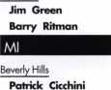

Birmingham

Bob Feldhouse

East Lansing

Jerry W. Michael

Howell

Edward Clawson

Jenison

Bonnie Huizen

Port Austin

Raymond C. Heins Traverse City

Jim Root Dan Wolf

Pine City

Russell L Landreth CRL

Sponsor: Thomas P. Freehling CML

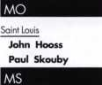

Vicksburg

William K. Crawford Jr

Apex

William Thomas

Archdale

Jerry W. Lee

Dobson

Dave Miller

Jackson Springs

Ronald J. McDonald Henry A. Sawyer Ira W. Gamer Jr Anthony W. Sacco Matthews Ben Mandell Monroe Tom Kaika Jay Woodward Reed Wilson Terrell

Thomas F. Mills

Sponsor: Alfred E. Nelson Winston Salem

Charles Hayes

Omaha

Joy J. Nelson

Sponsor: Dale A. Maichow CML

Nashua

Gail Perkins

Bridgewater

Garett S. Dorman

Camden

Joe Martin Cherry Hill

Jesse Hicks Jennifer O'Leary Justin Trueland

Elizabeth

Odains Echenique

Fair Lawn

Avner Etzioni

Glendora

Todd G. Cramer

Hackensack

Vincent Coniglio Mark Loop

Hamilton

Roland K. Brown

Kendall Park

James Butman

Mays Landing

Richard Gunter Phd

Monroeville

Robert P. Sweeten

Morristown

Stewart Levine Mount Laurel Moshe Veisblatt New Brunswick Richard Caporoso Lexine Skinner-Simmons Piscataway Kevin C. Kuharich Princeton Sandy Clark Red Bank Susan Novak Toms River Timothy Smith Trenton

Stephen J. Bama

These applicants are scheduled for clearance as members of ALOA. The names are published for member review and comment within 30 days of this Keynotes issue  
date, respectively, to ensure applicants meet standards of ALOA's Code of Ethics. Protests, if any, should be addressed to the Membership Department and must be  
signed. Active Membership applicants (a) have worked in the industry two or more years. Allied Membership (AL) applicants are not locksmiths, but work in a security-  
related field. Apprentice Membership (AP) applicants have worked in the industry less than two years.

Keynotes • October 2004



Las Vegas

Tan D. Aquiles

NY

Baldwin

Ira Weiner

Bronx

Alex Bolotovsky Steve Talisman Ed Cass

Anthony DeRosa Raymond W. Herskovits RL Brooklyn William Blaut Stephen W. Britton Moe Sajjud Daniel France Cathy Fuda-Sajjad Joseph Inga Hal Levenstein Amos Samuels Moishe Soifer Mike Tomshinsky Chittenango Eva Rosko East Elmhurst Max Tam East Northport Sid Gordon Farmingdale

James Reilly

Flushing

Sharon Shemesh Connie Wu New York Jason Horowitz Eric Howard Wai Kin Ng Charles Schnabolk Charles Schnabolk North Syracuse Brian Casler Port Chester Rajiv Sanga Queens Village Gittu Modi Rochester

Richard Manuele

Sponsor: Roger C. Yost CMk CPS

Salisbury Mills

ED York

Spring Valley

Greg Galbo

Suffern

Naji Wassaf

West Islip

Pat Curiale Joy Festa

Yonkers

Mike Hughes

OH

Bellevue

Helen Blakely Mark Blakely

Canton

Michael K. Potter

Cleveland

Mitchell Bass

Columbus

Chris Warren Muriel Stafford

Dayton

Michael Leopard

Elyria

Mark Guggenbilier Raymond D. Peters

Mentor

Moti Drori

Miamisburg

Kevin Donahoe

Sponsor: James S. Mayes

Northfield

Pat Jones

Pickerington

Anette Carrel Bill Carrel

Pioneer

Richard W. Frankel

Prospect

David P. Hook

OK

Ada

David Taylor

Durant

Keith L Cook

Sponsor: Clifford D. Lipscomb CML, CPS Norman

Travis Scott

OR

McMinnville

Dick Patterson

Portland

Nancy Moore

PA

Abington

Patty Trott

Akron

Stephen Hildebrand

Allentown

Glenn Bechtel

Annville

Dorothy L Burriss

Bensalem

Edward **Pyffer**

Berwyn

Charles Stead

Bethlehem

John Rendle

Bristol

Bryan Chew Ken Chew Sr Ken Chew Jr Charles **Jacobs**

*Carnegie*

**Russell Stephan** Cheltenham **Steven** Horwitz Chester Springs Rich Hilton Jim Jackson Concordville Michelle Glynn Coraopolis Leo S. Firanski Jr Colleen Firanski Doylestown Bob Simpson Drexel Hill Stuart Cohn Bill Kline Neal Abel Franklin

William M. Gutmiller

Hanover

Lawrence **Weinstein** Harrisburg **Frank Belkins** Hazleton Terry Walz Jerry Mekolichick Honesdale

Barbara Blockberger Judith Patten

Lancaster

Collette Leonard Thomas O'Malley

Langhorne

Rich Keefe

*Mackeyville*

Ronald Staut

Akilvern

Robert A. Hoeflein

Manheim

Ernest Winter

Mohnton

James Springhom Philadelphia

Alan Good John Kairis Roland R. Koerner Irvin Bruskin Demetrius Heggs Thomas O'Shields William Sparks Sam Weiner Pittsburgh Jeff Wagler John Allison Shawn Bishop William Crawford Pat Haney Ed Mooney Raymond Rose Pocono Pines Donna Kerrick John E. Kerrick

Portland

Kenneth W. Card Sharon Hill Jim Murphy

Southampton

Dubov Vitaliy

Warminster

Ben Cogan Nelson Shane

Wayne

Denise Dayton

Wilkes Barre

William Troth

Wynnewood

Matthew Scher

York

David Kotz Julie Malloy

PR

Mayaguez

Karlos J. Ortiz

SC

Charleston

David W. Spears

Greer

Wallace Seaborn

Spartanburg

Donna Kuhens Sage Kuhens

TN

Hermitage

Todd Wilson

Johnson City

George Carver

Nashville

ND Rose

TX

Allen

Gary Rogers

Arlington

Enrique Miranda Delgado Jesus Mari Insunza Robert McConnell

Dallas

Mordehay M. Mizrahi

Garland

James C. Fitzgerald

Sponsor: James L. Hancock CPL Kerrville

Ricky Raney

Sponsor: James L. Hancock CPL Plano

Craig Gilbert

Springtown

Jerry Lee

UT

North Salt Lake

David Anderson

VA

Alexanderia

George Stone Alexandria

Mark Fetterolf Lonnie Jones Karl Dabbe Brandon Mauch Jason Moss Tom Pivovarnik Arlington Doug Buzbee Jack Dunlap Ricardo Iglesias Cliff Leidig Ashland

Eichelle L Hamaker

Cedar Bluff

Daniel Horn

Centreville

Nancy Cunningham Robert Cumingham

Chantilly

Molly Long Roger Roehr

Fairfax

Darrell B. Luskin CML

Falls Church

Charles Barton Robert Baron

Fincastle

Jeff Bowles

Franklin

James M. Fournier Glen Allen Brett Davis

Hillsville

Brian Kuhens

Lorton

Clancy K. McDonald

Louisa

Jack Buckley

Manassa

Michael Corbett Manassas Diane Amaoui Courtney Earll

McLean

Randy Crump Bruce Etzweiler Ray Rybicki Mount Jackson Dee Ann Diaczynsky Newington Tom Black Brandon Calderon John Huntt Newport News Dan Alexander Kenneth J. Lange Palmyra

Bradley Small

Quantico

Kenneth Shelden

Reston

Julie A. Myren Richmond Ross Bailey Kevin Haselbush Bruce W. Neiss Donald Proctor David Spear Kenneth Adams Roanoke

Duane Perdue

Salem

Gail Anderson Barbara Bradburn

Spotsylvania

George W. Jett

Springfield

Bob Adams Jay Dalton

Stafford

Bruce Maye

Staunton

David S. Armstrong Scott L Cash Sarah Crummett

Sterling

Michael P. Maroney

Sponsor: Spencer P. Caple CRL Suffolk

Charles E. Reid NancyLee Reid Virginia Beach Cecil D. Thornton West Point Mark Bickerton Winchester Michael P. Burt Sean Sicher Joshua Vossel Donald L. White Sponsor: John E. Cawby Woodbridge Dorothy Royer Duaine Patton

Wl

Fort Atkinson

John Diedam

Milwaukee

Carol Peterson

South Milwaukee

Frank J. Pranghofer

Sponsor: John W. Soderland CML, CMST

Wisconsin Rapids

Keith Reed

Sponsor: William O. Doucette

wv

David Paugh Mount Hope Thomas Kessler

Araentina

Buenos Aires

Australia

Canberra, ACT

John Kis Gavin S. Rae

Canberra, Alt

Peter Searle

Mascot NSW

Marc Cohen

Victoria

David Weinel

QL Gold Coast

Dean P. Campbell



Brussel, Brabant

Bervoets Mario

Canada

Halifax, Nova Scotia

Ron Gunter

BC

Richmond

George Drimas

Vancouver

Brian Hoskins

ON

Gloucester

Marcel Goulard Hamilton Bob Schofield Mary Schofield

Oakville

Mary Penrose Valentin Bradu

Ottawa

Kenneth Clupp

Rexdale

Tom Zissopoulos

Scarborough

Karen Johnston

St. Catharines

Brandon M. Pinder

Toronto

Demetrios Zissopoulos PQ Montreal Francois Goyette Rejean Savage QB LaSalle Victor Brassard

China

Taizhou

Ke Ping Lin

□land

Gateshead, Tyne & Wear

Colin Rose

France

Paris

Caroline Peyronnet

Italy

Conegliano (TV)

Pierluigi Oliana

Italy

Robert Landori

Japan

Tokyo

Naoki Maeda Akihiro Nakamor

Korea

Gyeonygi Do

Jae Won Lee

Seoul

Dong Hee Lee

Peru

Lima

Luis Philipps Francisco Clausen Soles

Philippines

Rizal

Allan S. Paredes

Russia

Moscow

Ushakov Gennady Alexey Petrov

Sweden

Kungens Kurva Stockholm

Lars Asklof

□land

Bristol

Bernard Wells

Sponsor: Nick T. Joanes Gloucester

Steve Rudge

Hemg Hempstead, Herts

Sam Beighton

London

Dave Turrell

United Kingdom

Hemel Hempstead, Herts

Steve Long

Derby

Tim Latter

Sponsor: Ken Dale Eastbourne, Sussex

Martin McCaffrey

Keynotes • October 2004

upcoming events

|  |  |
| --- | --- |
| New York Master Locksmiths' Assoc Monthly Meeting  Every Second Wednesday NYC/Long Island Area  718 274-6930 | 6 Ohio Valley Chapter of ALOA 6 Minnesota Chapter of ALOA 7-10 M.I.N.K.  Monthly Meeting Regular Meeting, Dinner 6:00 PM, Omaha, NE  Ryan's Steakhouse Meeting 7:00 PM, Program: MN Contact: Bernard Dobesh  Middleton, Ohio Sales Tax or Homeland Security 308-381-4440  513-464-1299 |
| 12-16 Pacific Locksmith Conference - Portland, Oregon | 13-16 Institutional Locksmiths' Assoc. 20-24 Yankee Security Convention 27-30 GPLA Annual Convention  2004 ILA Conference ACE Classes, Trade Show & PRP Radisson Hotel • Mt. Laurel, NJ  The Hotel Roanoke and Confer- Sturbridge, MA  ence Center - Roanoke, VA |
| 27-31 GPLA 2004 Convention  Radisson Hotel Mt. Laurel, NJ [www.gpla.org](http://www.gpla.org)  Exhibitors call Edward Fitzgerald, CML at 856.665.1311 |  |
| New York Master Locksmiths' Assoc Monthly Meeting  Every Second Wednesday NYC/Long Island Area  718 274-6930 | 3 Ohio Valley Chapter of ALOA 3 Minnesota Chapter of ALOA 20 Oklahoma Master Locksmith Assn.  Monthly Meeting Regular Meeting, Dinner 6:00 PM, Basic electronics education  Ryan's Steakhouse Meeting 7:00 PM, Program: MN seminar and membership meeting.  Middleton, Ohio Sales Tax or Homeland Security Holiday Inn Select in Tulsa.  513-464-1299 405-919-0235 |
|  |  |

|  |  |  |  |
| --- | --- | --- | --- |
|  | 1 Ohio Valley Chapter of ALOA | New York Master Locksmiths' Assoc. 6 | Minnesota Chapter of ALOA |
| •  ij | Monthly Meeting | Monthly Meeting | Annual Banquet, Dinner 6:00 PM, |
| 111 | Ryan's Steakhouse | Every Second Wednesday | No Meeting |
| a | Middleton, Ohio | NYC/Long Island Area |  |
|  | 513-464-1299 | 718 274-6930 |  |

UPCOMING ACE CLASSES UPCOMING PRP SITTINGS

|  |  |  |
| --- | --- | --- |
| 10/7-8/2004 | Omaha, NE • MINK Convention • Bernard Dobesh 308-381-4440  CPS Prep Class <http://www.nebraska-locksmith.com/> | 10/2/2004 |
| 10/12-16/2004 | Portland, OR • Pacific Locksmiths Association • Tom Jones, CRL 503-842-2944 • Basic Locksmithing 1 & II (twice) <http://www.pla-pro.org/plc/index.htm> • Life Safety Codes w/L-07 PRP Servicing Aluminum Storefront Doors  Master Keying Methods & Formats 1 & II  Late Model Steering Column Service • Power Door Openers  Hollow Metal Doors & Frames • Intermediate Auto Lock Service  Exit Devices & Exit Alarms w/L-16 PRP  Professional Impressioning Techniques • Transponders  The Complete Door & Door Closers w/L-05 PRP  Professional Lock Picking | 10/3/2004  10/3/2004  10/10/2004 |
| 10/14/2004 |
| 10/15/2004 |
| 10/20-24/2004 | Sturbridge, MA • Yankee Security Convention • Jack Hobin 800-209-8266 • The Complete Door & Door Closers w/L-05 PRP [www.yankeesecurity.org](http://www.yankeesecurity.org) [info@yankeesecurity.org](mailto:info@yankeesecurity.org)  Basic Locksmithing 1, II & III • High Security Cylinders w/L-08 PRP  Exit Devices & Exit Alarms w/L-16 PRP • Basic Electricity w/L-13 PRP Keyless Mechanical Locks w/L-20 PRP • Tubular Key Locks w/l-12 PRP | 10/23/2004  10/31/2004 |
|  |
| 11/13/2004 |
| 10/25-30/2004 | Appleton, Wl • Fox Valley Technical College • Jerry Antoon P- 920/735-2406 • 6 Day Basic Locksmithing Course  Fox Valley Technical College F-920/735-2414 | 11/14/2004 |
| 11/13/2004 | Atlanta, GA • Georgia Chapter of ALOA • Kevin Wilson, CML,CPS 770-279-1161 • PRP Prep Class | 11/11/2004 |
| 11/13/2004 | Detroit, Ml • Locksmith Security Association • Robert Nobel, CPL 810-385-9329 • Combination Lock Servicing w/L-24 PRP | 11/20/2004 |
| 11/13/2004 | Kalamazoo, Ml • Western Michigan Locksmith Assn.  R. Paul Bentley, CPL 269-327-8400  Complete Door & Door Closers w/L-05 PRP | 12/9/2004 |
| 11/20/2004 | St Louis, MO • Bi-State Chapter of ALOA • Robert Theobold 314-340-6801 • Alternate Entry Techniques |  |
| 12/4/2004 | Birmingham, AL • Alabama Locksmiths Association • DLee Schofield 334-8324920 • Simplex Unican Certification |  |

Saturday 9:00am • Colorado Springs, CO  
Central & Southern CO Locksmith Assn  
Gordon Racine, CML 719-3844707

Sunday 8:00am • Anaheim, CA • Clark Security Products Joan Emrick  
619-718-7308

Sunday 9:00am • Brandon, FL • SERLAC  
James Barnhardt, RL 813-689-5979  
Saturday 8:00am • Omaha, NE • MINK Convention  
Bernard Dobesh 308-381-4440

Thursday 8:30am • Dallas, TX • ALOA • Hope Rodriguez 800-532-  
2562x30

Friday 6:00pm • Portland, OR • Pacific Locksmiths Assn  
Dan Cunningham, CRL 360-835-7131

Saturday 9:00am • Sturbridge, MA • Yankee Security Convention •

Jack Hobin 800/209-8266

Sunday 10:00am • Mt Laurel, NJ • GPLA

Robert J. Schuetrumpf, CRL856486-9280

Saturday 8:00am • Cary, NC • NC Locksmiths Assn

Granger L. Marley, CML 919-859-6060

Sunday 1:00pm • Robinsonville, MS • Tennessee Organization of

Locksmiths • Jim Weidman, CPL

615-837-1264

Thursday 8:30am • Dallas, TX • ALOA • Hope Rodriguez 800-532-  
2562x30

Saturday 8:00am • Atlanta, GA • Georgia Chapter of ALOA Kevin

Wilson, CML,CPS 770-279-1161

Thursday 8:30am • Dallas, TX • ALOA Hope Rodriguez

800-532-2562x30

core

LARRY D. SPEARS

HIT & RUN VICTIM IN CRITICAL CONDITION

Until Friday, August 13, 2004 Larry Spears (husband of TLA member/board member Michelle Spears and son-in law of Judy & Buddy Clifford) had been an active man who enjoyed his life to the fullest. His life changed in a split second. While enjoying an evening of fishing on Bryan Beach with friends, a drunk driver struck Larry down and fled the scene. Larry was taken to UTMB hospital in Galveston, Texas by LifeFlight where he underwent 1 2 hours of surgery to repair the many life-threatening injuries he received. Larry's mobility has been compro­mised but he is able get into a wheelchair with assistance. His wife, Michelle, has found it necessary to cut her work hours to a bare minimum in order to take care of him. The Spears children; Ashley, Brian, and CJ. are also assisting Michelle with his care. There are most certainly further medical procedures and many months of extensive physical therapy to follow before Larry will be able to have a better quality of life. A benefit account has been set up for Larry and his family, at First State Bank of Lake Jackson • 490 This Way • Lake Jackson, Texas 77566 • Account # 6031983. The will also be a fundraiser on October 9. For more information, contact Michele Gregory at 979-236-7998.

Pascal's Triangle Website Error

If you are doing an internet search for Pascal's Triangle (as mentioned Keynotes June 2004 article on Page 12 "The Magic of Spherical Master Keying Part 2" by Eric Costley, CRL.) Be aware of an error on the Pascal's Triangle website, <http://ptril.tripod.com/>. The numbers across the 13th line contain the number 186. It should be 286.

Master Lock serves Special Needs Students and Workers with ADA Series Locker Locks

Master Lock company is offering a built-in locker lock with a large key head that helps special needs students, customers or workers easily open lock doors.

The Model 1710ADA features deadbolt locking for high security and a 5-pin tum­bler cylinder for pick resistance. The lock fits both left-handed and right-handed doors and is available keyed-alike, master key and group key, to meet a facility's needs. The large key head is easy to operate. The key code is visible inside the key head and both the key and key heads are replaceable. In addition, the key head is available separately (Model No. 1710-439-59). The locker lock is also available with a spring-bolt locking mechanism (Model 1714ADA), ideal for box lockers and single-point-latch lockers. For more information, visit the website at [www.masterlock.com](http://www.masterlock.com).

New Schlage D-Lock Aces the Test

Schlage's new D-Lock is passing the test at Adams County School District 12 schools in Thornton, CO. The lock is being tested on 10 high-traffic, high-abuse doors in Thornton high and middle schools.

"The doors we are testing get a great deal of very hard use.", said Dave Thielen, CML and ALOA's ACE Award winner for 2004 "Because teenagers are so extremely rough on the locks, we need a durable lock that can withstand daily abuse."

In the past nine months since the new D-Lock has been installed in the schools, Thielen has not had to replace any of the test locks. Thielen contributes with to the new D-Lock's stronger latch bolt and less drop on the lever. "The new D-Locks are a much tighter fit than the older ones", said Thielen. Thielen would like to get new D-Locks installed in all of the school district's 54 buildings. "The are worth every penny.", said Thielen.

SELECT Hinges Introduces New Stainless Steel Pin & Barrel Continuous Hinges

SELECT Hinges now offers stainless steel continuous pin and barrel hinges for situ­ations requiring stainless steel in addition to its performance-proven continuous- geared aluminum hinges. SELECT's new stainless pin & barrel continuous hinges match, contrast or accent your building's design. Adjust-A-Screw fastener let you square doors accurately and easily in new or retrofit installations and allow for future adjustments. Tamper-resistant covers guard against vandalism and reduce the hassle of frequent repairs. Pin & barrel hinges are guaranteed to be free of material and workmanship defects for 10 years. Visit[www.select-hinges.com](http://www.select-hinges.com) for complete product information.

Mr. Dave Leeper Receives ALOA Lifetime  
Membership

Gordon Racine, CML, Southwest Director of ALOA presented Dave Leeper with a  
Lifetime Membership plaque and membership card. Mr's Leeper's contribution to  
the field of locksmithing has been noteworthy and he was very pleased to receive  
this honor. Dave Leeper has been an ALOA member since 1966

In Memory

Jack W. Kilgore passed away at his retirement home in  
Georgetown, Texas on May 25, 2004. His long and  
successful career began when he was thirteen-years-old  
and became an apprentice locksmith. After his military  
service, Jack resumed his career by opening Industrial  
Safe and Lock Co. in Dallas, Texas which he operated  
for 40 years. Jack was renowned throughout the United  
States for his expertise in bank vault equipment. He was

a Past President of the Greater Dallas Locksmiths Association. In May of 1979,  
Jack was featured in a 3-page Keynotes article about his career.

In some ways Jack was very typical of the "old school" locksmith. But in so many other ways, he was anything but typical. He learned locksmithing the hard way, sweeping up key cuttings after school ("manicuring the floor", as he often described it) and making deliveries on his bicycle. His spirit of adventure and enthusiasm reminded people of a young boy on the bike.

Jack Kilgore is survived by his wife, Shirley Brantley Kilgore, two sons Michael Edward Kilgore and Gary David Kilgore; two granddaughters, Candace and Lindsay; four step-sons; five sons; five step-grandchildren and numerous devoted friends.

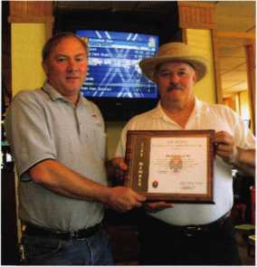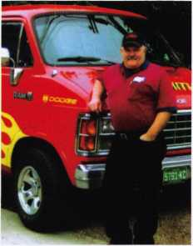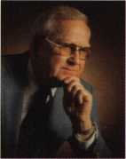

BACK FROM IRAQ

By: Claire L. Cohen, CML

Don Shiles is back from a six month tour of duty in Iraq. A name well recognized for his knowledge as an expert locksmith and a leading authority on lock forensics, his multi­faceted career began in 1955 and has touched countless people.

Serving in the military intelligence field in enlisted ranks (up to and including Sergeant Major), and as an officer (Captain and Major), his career spans 50-years. An expert in many aspects of physical security and military intelligence, Don is truly a multi-talented individual. He has a Masters degree in Psychology, and teaches painting at a local com­munity college. With his wife, Gaylie, they operate an art studio.

Don’s early career was begun as a Military Intelligence Specialist in the Army, where he  
learned about locks—how to install them, fix them, pick them and examine a

lock to determine if surreptitious entry had occurred. He is an expert in lock  
technology ranging from defense against methods of entry to protecting  
and securing classified documents. He can recognize the weaknesses of  
locking devices and suggest possible bypass methods.

Serving in Vietnam in the 1970’s, Don was a Company Commander  
and a Security Specialist. After retiring from the Army in 1989, he held  
a position in the Navy Intelligence Command in Washington, D. C.  
working in the security field, but not with physical locking devices.

Twelve years ago, he assumed a civilian instructor position at a military  
base, Fort Meade, Maryland, located just outside of the Nation’s  
Capital. In this capacity, Don was instrumental in developing the first  
Counter-Surreptitious Entry Course. This two to three week  
course covers all U.S. government security containers and

locks, all types of key operated locks, numerous access  
control devices (including biometric), automotive  
security devices, tamper indicating seals, security  
device by-pass techniques and investigative

(forensic locksmithing). The course covers  
many known means of lock penetration and  
trains students in conducting investigations.  
The course is taught only to government  
employees and military members who are  
engaged in investigative and/or security  
work.

A short time after Don submitted his civil-  
ian retirement application, he was asked by

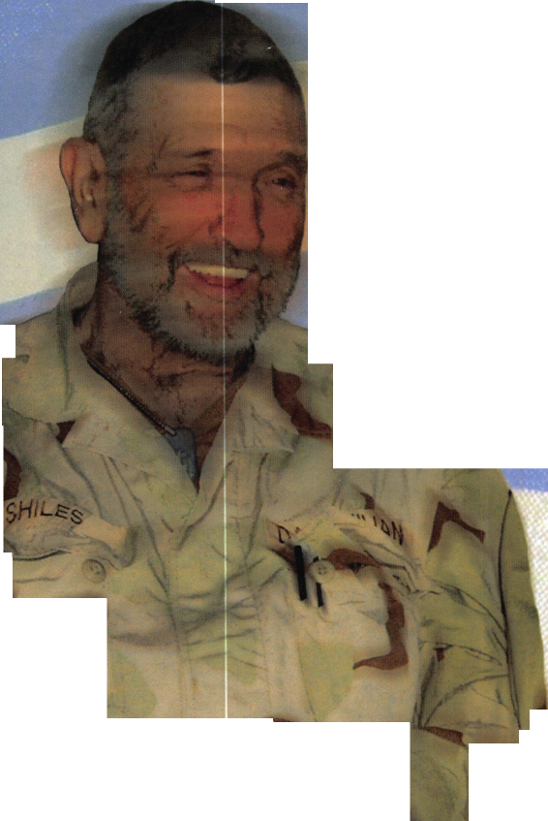

The vast majority of the Iraqi people are thankful the) have been released from the grip of Saddam’s

terrorist

regime

the

Army to  
participate in a  
military intelligence  
project: “Task Force Vigilant  
Freedom” in Iraq. He had intelli-  
gence background in Iran and Iraq, and a  
long-time connection with citizens in Syria and  
Afghanistan. At age 67, Don decided to postpone his  
retirement plans so that he could give six more months of  
service to his country and serve in Balad, Iraq. “I couldn’t say no”.

One of 18 civilians on the mission, Don was one of the oldest people going  
into the field in Iraq. To prepare for the trip, he had three weeks of intensive  
training. Equipped with approximately 50 pounds of “gear”, including a heavy bullet-  
proof vest, he was outfitted with the same weapons and apparatus of any of the soldiers. He  
did everything “the younger guys did. I wanted to show them they weren’t alone over there. If what  
I did will inspire somebody, then it’s worthwhile”.

He was an advisor, teacher and technical expert. As “Technical Consultant on Security for the Department of  
Defense”, he advised military units on the types of locks that should be used, when to use them and where to use them.  
He examined locks to insure that they were of sufficient quality for a particular job application, repaired locks, picked locks,  
and was involved in lock forensics. He was called upon to evaluate safe locks and to explain which safe locks could be  
manipulated, the differences between Group I and Group II locks, and the reasons to use higher security safe locks, such  
as the X07 vs. X09 lock.

Although he taught classes throughout the day, his classes were so popular that he spent many evenings running informal classes and seminars on lock construction and bypass techniques. “Everyone wanted to learn from enlisted personnel to Lt Colonels!”



Keynotes • October 2004

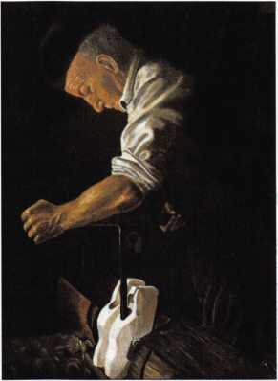

Don has a Master’s degree in Psychology, and teaches painting at a local communi­ty college. With his wife, Gaylie, they operate an art studio

"Shoemaker" by Don Shiles

"Christmas Cowboy" by Don Shiles

In Balad, with the aid of interpreters, his tacti­cal intelligence job involved talking to locals about where arms caches were buried and when attacks would come.

In Iraq, Don was a person in uniform, carrying weapons, riding in convoys, meeting with Sheiks, with farmers, teachers, police chiefs, members of the Iraqui Civil Defense Corp, children and orphans and other members of the Iraqui communities. He traveled in convoys from Kuwait City, Kuwait to Mosul (in the far north) with stops at all major cities and many towns and villages. Job satisfaction came “just helping the local people”.

Iraq was “hot, dirty, boring, and sometimes exciting”. He was very much aware of the dan­ger. The Balad compound was shelled many times by rocket fire and mortars. Don was very much aware that something could happen, but didn’t fear that he was in too much danger. A seasoned and professional soldier, he said “Either it lands in your lap or it doesn’t”.

Don was extremely impressed with the profes­sionalism of the U.S. military personnel he encountered in Iraq. He recognized that many of his fellow troops had been his students at Fort Meade. Don’s first-hand personal impres­sion is that “the vast majority of the Iraqui peo­ple are thankful they have been released from the grip of Saddam’s terrorist regime. They are appreciative of the sacrifices the U.S. is making in having the soldiers in Iraq. They are grateful for the opportunity to find some personal free­

dom in their lives for the first time in the mem­ory of most of the people.

In June, Don returned to the United States. He has been promoted to Director of the Technical Counterintelligence School at Fort Meade, Maryland. In addition to administrative duties, Don will teach classes in Forensic

Locksmithing. Back from Iraq, with memories of the people, and the satisfaction of knowing that he helped his country, he continues to teach in his field of expertise. He will also con­tinue his duties as President of the International Association of Investigative Locksmiths (LAIL), lecture all over the world, and help run an art studio. “I’d go crazy if I retired.”

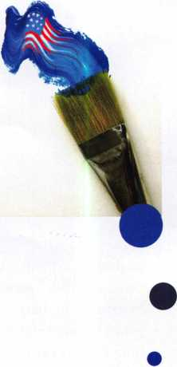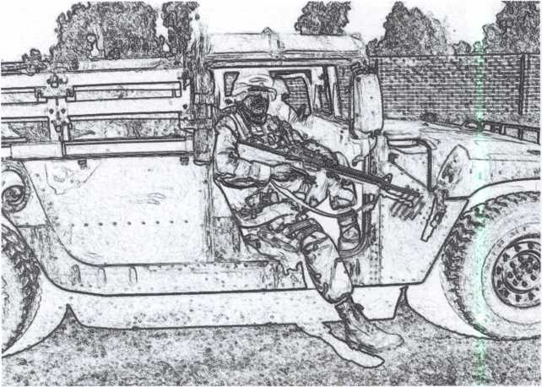

**2**

Keynotes • October 2004

Sweet Home Chicago

**RLOR 2005**

Up to $300 savings on ALOA 2005 Convention registration

**Hll members  
who reneui  
on or before  
January 1,  
2005, mill  
receiue:**

**PLUS! Brand New members also receiue immediate access to thousands**

**of keycodes with a free trial membership to Blackhawk 7.com**

Automatic Entry into a drawing for a 36” Sony Plasma HDTV

**Get MORE** with RLOR’s  
Biggest Membership Driue EUER!

A 10% discount for any purchase at the ALOA Bookstore

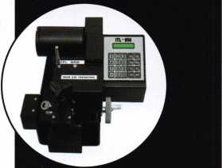

Automatic Entry into a draw­ing for a Key Machine (actual model not pictured)

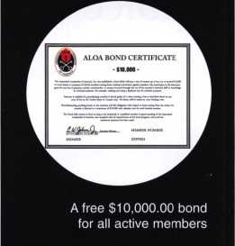

There is strength in numbers. MORE, means more uoices-more uoices to attract fresl blood. More uoices to increase consumer awareness. Rnd more uoices to speal for/against new laws and regulations that affect the securitg industrg.

Get in the game!

* Recruit 1 neiu member before December 31, 2004 and receiue $50.00 off your oiun 2005 membership due; plus RLOR Luill Luaiue the $50.00 application fee for your new recruit. (**completed application and dues mus be submitted with your renewal to receiue credit)**
* Recruit 5 neiu members and recommend 5 others before June 2005 for an entry into the draiuing **(drawin to be held at the RLOR Conuention and Security Eupo 2005)** for a 7-Day Education and TRIP FOR 2 to the Rio 50th Rnniuersary Conuention in Las Uegas, Neuada. **{July 2006-airfare from continental U.S. only)**

Here's how it works: 1) Make copies of the ALOA Membership Application form (for additional forms, call (800)532-2562, email [membership@aloa.org](mailto:membership@aloa.org), fax (214)827-1810 or download from <http://www.aloa.org/memapp.cfm>. 2) Recommend an industry peer by filling out this coupon (make copies first) and mail to ALOA, Attn. Membership Drive, 3003 Live Oak Street, Dallas, Texas 75204.

We will send your colleague an information kit with with notation that they are receiving this invitation to join per YOUR recommendation. When your "sponsoree" signs up, we'll send you notification so you can keep count.

Name of Sponsor (current ALOA Member)

Name of person recommended for membership

Address

City State Zip Country

Phone Fax Email



Bread and Butter Picks

By: Eric Costley, CRL

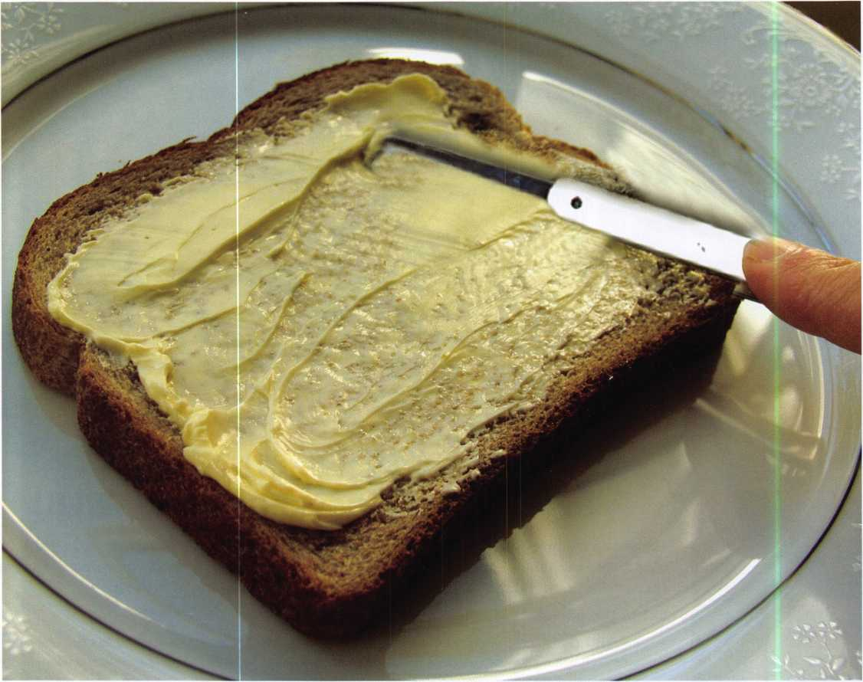

The choice of tools may vary and the wide-array of options on the market reflect the personal choice and specific training of a locksmith.



Keynotes • October 2004

There are two basic abilities which set the locksmith apart from the basic handyman, construction worker, hardware store employee and carpenter: these are impressioning and the ability to pick locks. Sure, there are other things that put us on a different plane, but these two skills are specific to locksmiths, and locksmiths only.

When I first began my lengthy career, I was amazed and intrigued at my feeble ability to pick a simple lock. Twenty-four years later, I am more skilled, but no less amazed. In addition to skill, I have learned over time that the choice of tools required to pick any given lock may vary and the wide array of tools on the market reflect the personal choice and specific training of any given locksmith. In simple words, we all use what works best for us. Some locksmiths prefer a rake, others a simple hook pick, and many of us have “favorite” tools which seem to work quickly and efficiently on most of the projects we encounter.

There are a variety of products on the market, and sometimes it becomes difficult to wade through what is a good invest­ment and what may be a potential waste of money. I have known used car dealers who got duped into buying expensive pick sets which in the end were only poorly-produced junk. When approached to buy these, I snicker. I have one such set which I use only as “broken picks”, which is to say that I use them to depress knob retainers and remove cylinder clips... I don’t care if I destroy them in the process! The particular car dealer that purchased these gave them to me at no charge. He was snowed by the sales pitch... “this set will pick any lock.” Yeah, right, and I have a nice statue in the New York har­bor that I can sell you really cheap.

I guess it was accidental that I started getting more selective about what picks and tension wrenches I use most frequently. Initially, my brother Brian supplied me with a small set of HPC picks. These are, have been, and probably always will be the “bread and butter” of pick sets. A rake, hook, double ball, half double ball, diamond, and the wonderful “large” hook were the staples that I cut my teeth on. It is a tribute to the manufacturer that after 24 years, a majority of my pick set con­sists of HPC tools. For beginners, I would recommend this set without reservation. However, get the nice big set with the zippered case. You’ll need the room for more!

**15**

Keynotes • October 2004

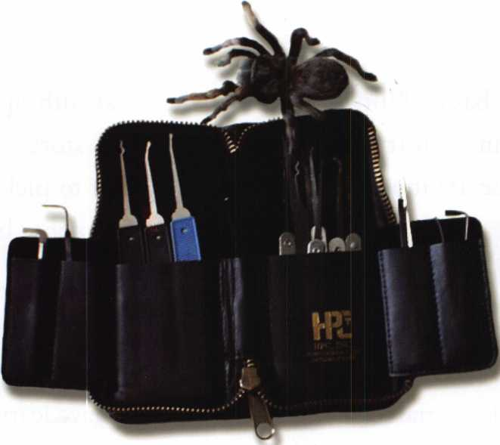

You never know what might crawl out of the author's pick set! Notice the Rytan to the left, HPC and Pro-lok to the right, a tension wrench ground down from an alien  
wrench to the far left, and a Peterson serrated tension wrench in the center pocket. Shoshona was not impressed, and crawled away.

Several years later, I stumbled across the Rytan picks. I was intrigued by the ergonomic handle, and the fact that every­thing that they make also comes in a “mini-pick”. The mini picks, equipped with a blue handle for quick selection, are excellent for smaller keyways, such as file cabinet locks and padlocks. Once I purchased a few of these, I was “hooked” so to speak. The “Deforest hook” is a combination of a hook pick and a half diamond, and remains my favorite pick to this day. Although I commonly used a HPC rake as my first pick of choice previously, I find that the Deforest works best for me. (Again, personal taste and opinion is at stake. Try it for yourself and generate your own opinion!)

So now you’ve seen that HPC and Rytan pretty much rule my world. Yes, but there are more fish to fry! Pro-lock, Peterson, and Southern Specialties picks are waiting in the wings, not to mention specialty picks such as A-l’s rocker picks, a variety of tubular picks, and a myriad of tension tools. Lastly, there is the new “fiber pick” from Pickmasters which created the initial inspiration for this series of articles but these are subjects for later consideration.

Peterson picks have been quietly sneaking into our industry for quite some time. I ordered a set recently just to see what all the buzz was, and I think I found another favorite to add to my arsenal of picks! The Peterson Reach is similar to the

Rytan Deforest hook, and I have found it very effective on locks which have a drastic difference between two adja­cent pins.

Peterson originally developed an elaborate tubular pick which they began marketing in 1999 that is capable of pick­ing Ace II locks, as well as virtually any other tubular lock. Once this hit the market, locksmiths started asking for “this and that” and the product line has expanded considerably. One of the really nice features of the Peterson line is that the picks are made of a heavier-gauge steel than many of the picks currently on the market which means durability and something that won’t bend or snap off suddenly while you are trying to let some little old lady in her house. (There’s nothing worse than having to dig the tip of your pick out of a lock at 10 degrees below zero while your customer is about to die of a combination of frostbite and old age!) The set of picks that I purchased also came with a tool for bending my own tension wrenches and a generous supply of spring steel to experiment with. Peterson also makes some “ready made” tension wrenches that I will rave about in a subsequent arti­cle but that’s another story. One last note on Peterson for this outing: one of my employers was eyeing the soft leather Velcro case, saying “Is that available by itself? That’s nice!” Also, the Peterson line is available in a variety of rubber, plastic, or textured handles. You can check out the Peterson



Keynotes • October 2004

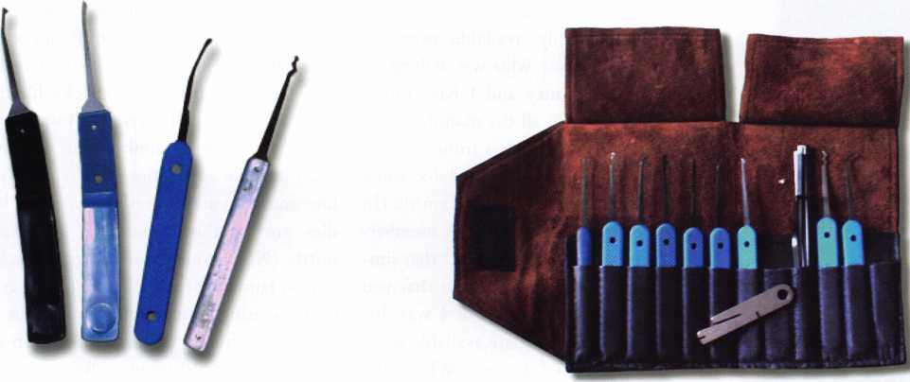

Rytan and Rytan mini side by side to  
theleft, the Peterson reach, and a rare Dominion rake  
that I hang onto for nostalgic reasons!

A nice assortment of Peterson picks, with the tool for bending your own tension wrenches  
in plain view. I was very impressed with the quality of this set.

line of picks on the internet at [www.peterson- international.com](http://www.peterson-international.com).

While I was bumping around the internet, I stum­bled on [www.lockpicktools.com](http://www.lockpicktools.com), the website for Southern Specialties. I was intrigued, and ordered their LRH-10 set. One of the things that caught my eye was the “ripple handle”, which I have found nearly as ergonomic as the Peterson or Rytan line. However, since they are metal, I will refrain from choosing them in the dead of winter! The picks and tension tools are of excellent quali­ty, and the LRH-10 comes in a nice hip pocket slimline case. In fact, it’s in my hip pocket at this very instant! Here again, another impressive prod­uct that I’m sure will find its way into my ever­growing arsenal of favorite picks.

Pro-lok manufactures a variety of locksmith tools which are available from your favorite distributor. The “potpourri” of assorted manufacturers in my favorite set includes a couple of their picks. Pro- lok picks are comparable to the HPC line, and therefore one of the staples that is always handy. Visit their website at [www.pro-lok.com](http://www.pro-lok.com).

**New!** Keedex Stainless Steel Armored Door Loops

ALL

NLESS STEEL DESIGN

STAINLESS

STEEL CONDUIT

STAINLESS STEEL

END PIECES

STAINLESS STEEL

MOUNTING SCREWS

YOUR

KEEDEX DISTRIBUTOR

MADE IN U.S.A.

COSTS NO MORE  
THAN MOST DOOR  
LOOPS THAT HAVE  
PLASTIC END PIECES

Call or write today for yourfree catalog!

Keedex, Inc.

12931 Shackelford Lane



Garden Grove, CA 92841  
714-636-5657 • Fax: 714-636-5680

e-mail: [info@keedex.com](mailto:info@keedex.com) **"Ideas That Work"** **[www.keedex.com](http://www.keedex.com)**

Keynotes • October 2004

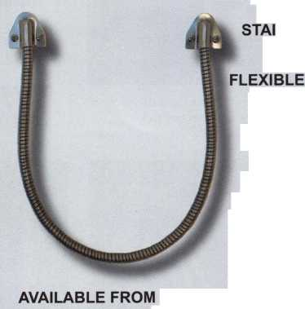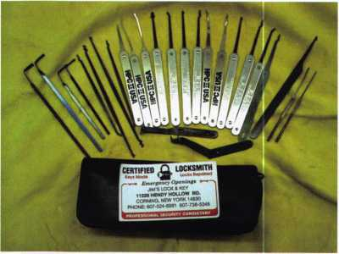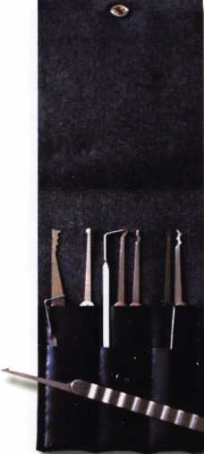

my favorite manufacturers of picks. The only qualm that I have with them is that their line is made of a thinner grade of steel which means that they tend to bend more easily than many other brands of picks. One of the wonderful things about Rytan is their blue-handled “mini” line, which is invalu­able when working with padlocks, file cabi­nets and other small keyways. Most conven­tional picks prove cumbersome and awk­ward in these applications where the Rytan line excels. In addition, the non-metal han­dles are weather-friendly in the frozen north. (Never touch your tongue to a flag­pole in January, or grab a metal pick that has been sweating condensation in the van just before you attempt to pick a lock at sub-zero temperatures!) Visit [www.Rytan.com](http://www.Rytan.com) or your favorite distributor to purchase the fine products available from Rytan.

When it comes to the staples that rule the industry, I cant say enough about the HPC line. Despite the metal handles, (see the above warning!) these have been the pick of choice for as long as I’ve been a locksmith. The sturdy design, availability and price have made them the measure by which all others must be judged. In time, these may be supplanted by some of the others which

Jim Rouse also relies strictly on HPC. Note the wide variety of  
key extractors and a few double-ended picks.

What’s in Your Pick Set?

The LRH-10 set from Southern  
Specialties. Note the nice ripple han-  
dles,and slimline hip pocket case."

Before I begin to elaborate on my two  
favorite lines, I have one axe to grind.  
Recently, in the name of research, I have  
purchased several sets of picks via the  
internet. I have heard for years that lock  
picks were readily available over the  
internet to anyone who was willing to  
shell out the money and I have found  
this to be true. Of all the manufacturers  
that I purchased products from over the  
internet, only Peterson asked for some  
proof that I was indeed a locksmith! (In  
fact, they asked for my ALOA member-  
ship number!) I know for a fact that sim-  
ply owning picks doesn’t mean that you  
know how to use them, but I was dis-  
turbed that such tools are available with-  
out reservation to anyone. What’s the  
solution? I don’t know. I have personally  
e-mailed these companies and implored  
them to implement some sort of restric-

tions. If you encounter  
other suppliers of lock  
picks who sell without  
any restrictions, I  
encourage you to do  
the same.

Rytan, as I’ve already  
mentioned, is among

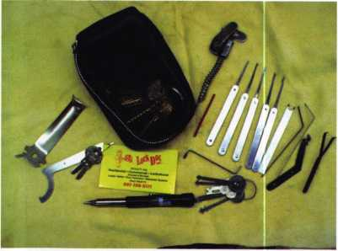

Carl Orozoco's pick set contains a plug spinner, a single  
Rytan pick, a host of HPC and a variety of extractors and ten-  
sion wrenches.

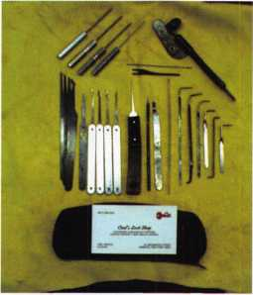

Mark Fuller, CPL, (one of my esteemed Earl Stedge is strictly an HPC man. Notice also that there  
employers,) carries a plug spinner, isn't a rake pick in sight!

some extractors, a combination of  
HPC and Rytan, and a knitting needle  
in his pick set!

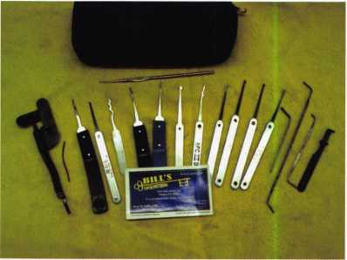

**18**

Keynotes • October 2004

I have mentioned, but at this point in time, HPC has set the industry standard. Check out their ever-growing line of products at [www.hpcworld.com](http://www.hpcworld.com), or visit your favorite dis­tributor. The new “glow pick”, (a combination of a flashlight with 14 different pick attachments,) indicates that HPC never rests in their attempt to implement new innovations into their product line. For the beginner, there is no substi­tute for HPC’s novice pick set and my own favorite assort­ment is housed in an HPC zippered case.

At our most recent local locksmith meeting, I asked every­one to grab their pick set and show me what was in it. There is an array of photos here which represents the wide variety of choice of each individual locksmith that attended. One of the obvious features is that HPC is represented heavily, fol­lowed by Rytan. Many locksmiths also carry a compact plug spinner in their pick set, and our buddy Mike Aug, CRL, also included some bump keys, Simplex tools, and some warded padlock picks. (Mike’s set was larger, as it was

housed in an old calculator case! Here again, what works best for you is the most important qualification!

There are many, many more things to discuss about lock picking, including tubular picks, new innovations, specialty picks, plug spinners, and tension tools. I intend to explore these in future issues. In the meantime, keep pickin’ and grinnin’!

One final word about picking locks: it is not the be-all, end- all when approaching a lockout situation. I don’t normally spend more than 20 minutes in an attempt to pick or impression a lock. (Well, maybe 20 minutes each.) There is a wonderful thing known as a “rotary pick”. (Translate this as DRILL!) The most important thing in any given situation is to complete the job at hand as quickly and efficiently as possible, and to be as professional as possible.

Stay tuned for part 2!

**THE HINGE DOCTOR**

**by GKL Products**

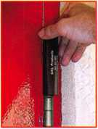

**HA1 For  
Standard**

**Commercial**

**4-1/2" x 4-1/2"**

**Butt Hinges**

**HA2**

***"The HULK****1*

**For Residential**

**COMING IN**

**SEPTEMBER For Ball-**

**Bearing**

**Commercial Hinges**

**HA4**

**For Prison**

**& Institutional**

**Hinges &**

**Spring Hinges**

**The Hinge Doctor is a great way to repair those sagging metal**

**doors. Slip the tool over the hinge and open the door an inch**

**or two past the point where the tool binds against the**

**hinge, remove the tool and check the door,  
which should now be working properly.**

**If you're a locksmith these tools  
will turn a profit the 1st time you  
use them!  
Uses - schools, hospitals,**

**commercial buildings, storefronts**

**with butt hinges, office doors, new**

**construction, door alignment, sagging  
doors, jail cells, anywhere there are  
commercial grade hinges.**

Over

**10,000**

Satisfied

Customers

US Patent

#6450003

**[www.hingedoctor.com](http://www.hingedoctor.com)**

**800-924-5397**



Keynotes • October 2004

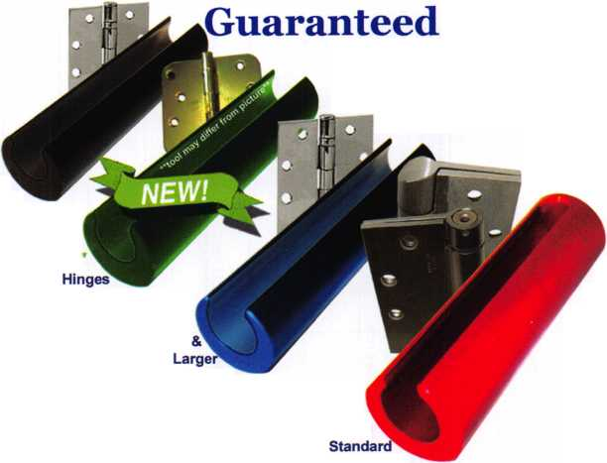

United States Postal Service

**Statement of Ownership, Management, and** Circulation

|  |  |  |
| --- | --- | --- |
| 1. PubflcationTWe | 2. Publication Number | 3. Fifing Date  Sept. 21, 2004 |
| Keynotes | 027 7-0 792 |
| 4. Issue Frequency  Monthly (bimonthly July/Aug) | 5. Number of Issues Published Annually 11 | 6. Annual Subscription Price Member Benefit |
| 7. Complete Mailing Address of Known Office of Publication (Not printer) (Sheet, city, county, state, andZIP+4)  3003 Live Oak Street  Dallas Texas 75204-6189 | | Contact Person  Betty Henderson |
| Telephone  214-827-1701 |

8. Complete Matting Address of Headquarters or Genera) Business Office of Publisher **(Not printer) SAME**

**9. Full Names and Complete Mailing Addresses of Publisher. Editor, and Managing Editor (Do not leave blank)** Publisher **(Name and complete mailing address)**

SAME

**Editor** (Name and complete matting address)

Betty Henderson 3003 Live Oak Street Dallas TX 75204-6189

**Managing Editor** (Name and complete mailing address) **.**

SAME

**10. Owner** (Do not leave blank. If the publication is owned by a corporation, give the name and address of the corporation Immediately followed by the

names and addresses of all stockholders owning or holding 1 percent or more of the total amount of stock. If not owned by a corporation, give the  
names and addresses of the Individual owners. If owned by a partnership or other unincorporated firm, give its name and address as well as those of

each Individual owner. d the publication tepifflished by a nonprofit orgemtoatlon,glve its name and address.)

**Complete Mailing Address**

Associated Locksmiths of America

3003 Live Oak Street Dallas TX 75204

11. Known Bond**hol**d**er**s, M**o**rtg**agee**s, and Offier Security Holders Owning or  
Holding 1 Percent or More of Total Amount of Bonds, Mortgages, or

Other Securities. If none, check box **^** □ None

|  |  |
| --- | --- |
| Fufi Name . | Complete Mailing Address |
|  |  |
|  |  |
|  |  |
|  |  |
|  |  |

**12. Tax Status** (For completion by nonprofit organizations authorized to mall at nonprofit rates) (Check one)

The purpose, function, and nonprofit status of this organization and the exempt status for federal Income tax purposes:

* Has Not Changed During Pre ceding 12 Months
* **Has Changed During Preceding 12 Months** (Publisher must submit explanation of change with this statement)

PS Form **3526**, October 1999

(See Instructions on Reverse)

13. Publication Title

|  |  |  |  |  |  |
| --- | --- | --- | --- | --- | --- |
| 15. |  | Extent and Nature of Circulation |  | Average No. Copies Each issue During Preceding 12 Months | No. Copies of Single Issue Published Nearest to Filing Date |
| a. Total Number of Copies (Net press nm) | | | | 8000 | ROOD |
|  | (1) | Paid/Requested Outside-County Mail Subscriptions Stated on Form 3541. (Indude advertiser's proof and exchange copies) | | 705? | 66-1-fi |
| b. Paid and/or Requested Circulation | (2) | Paid In-County Subscriptions Stated on Form 3541 (Include advertiser’s proof and exchange copies) | | 72 : | -3.3— |
| (3) | Sales Through Dealers and Carriers, Street Vendors, Counter Sales, and Other Non-USPS Paid Distribution | | Q ; 1 | -0 |
|  | (4) | Other Classes Mailed Through the USPS | | 0 | 0 |
| c- Total PaH and/or Requested Circulation [Sum of 15b. (1), (2),(3),and (4)] | | | ► | 7125 | 6691 |
| dFree  Distribution | 0) | Outside-County as Stated on Form 3541 | | 0 | 0 |
| by Mail  (Samples,  compliment | (2) | In-County as Stated on Form 3541 | | 0 | 0 |
| ary, and .other free) | (3) | Other Classes Mailed Through the USPS | | .0 | 0. |
| e Free Distribution Outside the Mail (Carriers or other means) | | | | 4J50 | 650 |
| Total Free Distribution (Sum of 15d. and 15e.) | | | ► |  | 650 |
| 9 Total Distribution (Sum of 15c. and 15f) | | | ► | 7575 | J3JL1 |
| h.  Copies not Distributed | | | | <*75 | 65 Q |
| Total (Sum of ISg. and h.) | | | ► | Boon | 8000 |
| i Percent Paid and/or Requested Circulation (15c. divided by ISg. times 100) | | | | 94.05* | 9-L..1-4& |

14. Issue Date for Circulation Data Below

16. Publication of Statement of Ownership

□ Publication required. Will be printed in the QdrODgf ZOOM issue of this publication.

**□ Publication not required.**

17. Signature and Title of Editor, Publisher, Business Manager, or Owner

Sept..21, 2004

I certify that all information furnished on this form is true and complete. I understand that anyone who furnishes false or misleading information on this form or who omits material or information requested on the form may be subject to criminal sanctions (including fines and imprisonment) and/or dvtl sanctions * 1 2 3 4 5 6 7

**(Including civil penalties).**

Instructions to Publishers

1. Complete and file one copy of this form with your postmaster annually on or before October 1. Keep a copy of the completed form for your records.

2. In cases where the stockholder or security holder is a trustee, include in items 10 and 11 the name of the person or corporation for whom the trustee is acting. Also include the names and addresses of individuals who are stockholders who own or hold 1 percent or more of the total amount of bonds, mortgages, or other securities of the publishing corporation. In item 11, if none, check the box. Use blank sheets if more space is required.

3. Be sure to furnish all circulation information called for In item 15. Free circulation must be shown in items 15d, e, and f.

4. Item 15h„ Copies not Distributed, must include (1) newsstand copies originally stated on Form 3541, and returned to the publisher, (2) estimated returns from news agents, and (3), copies for office use, leftovers, spoiled, and all other copies not distributed.

5. If the publication had Periodicals authorization as a general or requester publication, this Statement of Ownership, Management, and Circulation must be published; it must be printed in any issue in October or, if the publication is not published during October, the first issue printed after October.

6. in item 16, indicate the date of the issue in which this Statement of Ownership will be published.

7. Item 17 must be signed.

Failure to file or publish a statement of ownership may lead to suspension of Periodicals authorization.

PS Form **3526**, October 1999 **(Reverse)**

detection systems

Altronix

0AIPHONI

Mmmtmw

ACCESS ABILITY

Ability to get the best.

Security’s Electronic Access Group can provide everything you need to design and integrate the most complex and demanding access control system - the ideal components, from every major manufacturer - right down to the wiring. That’s single-source supply, with technical knowledge and immediate availability and shipping. Rely on Security Lock Distributors and you’ve got the ability to do your best.

1-800-847-5625 mSECUMTY

L>QJl LOCK DISTRIBUTORS

[www.securitylockdistributors.com/email](http://www.securitylockdistributors.com/email): [info@seclock.com](mailto:info@seclock.com)

Boston, MA • Pompano Beach, FL • Las Vegas, NV Informed. In depth.

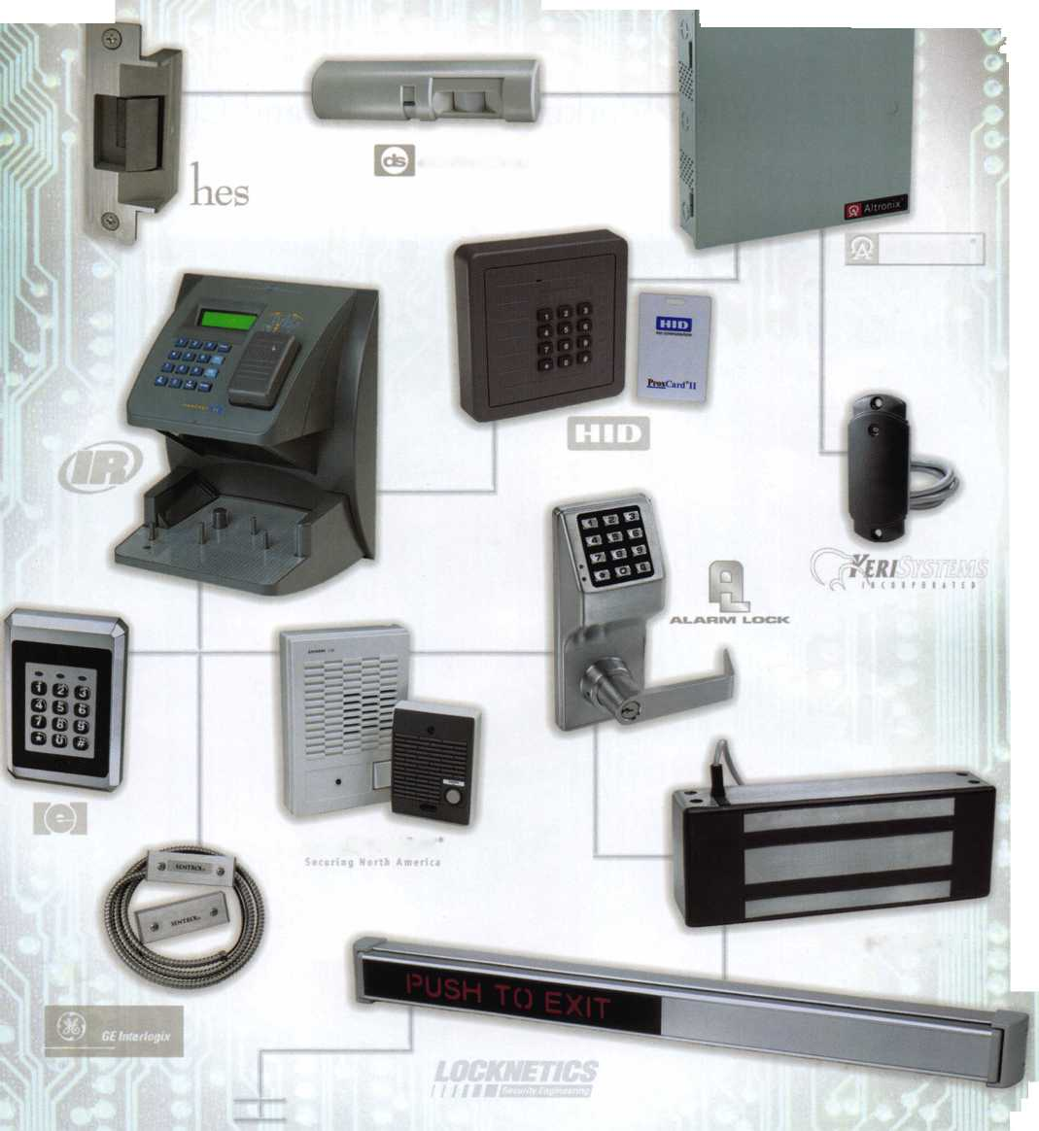

Trading Information

Keep Your Head When Working with Codes and Concrete

By: Greg Perry, CML, CPS

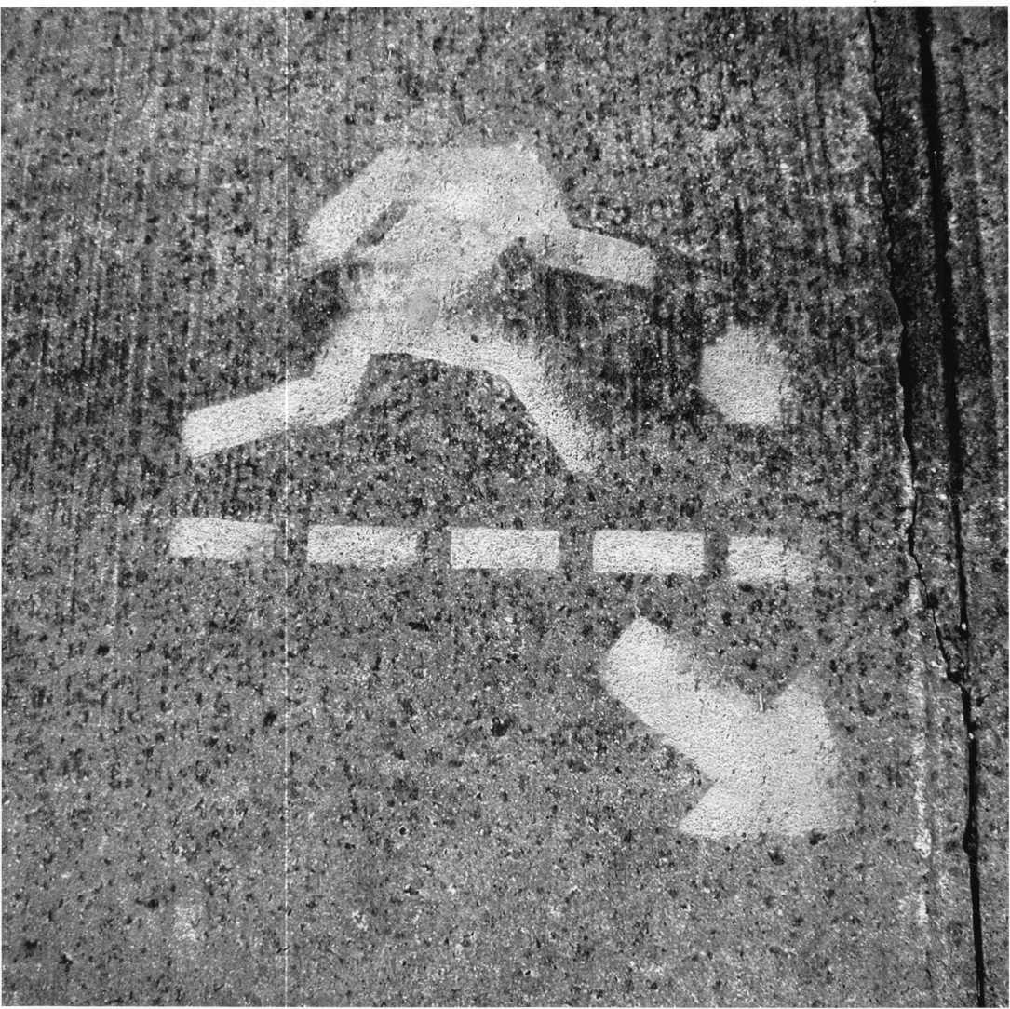

**22**

Keynotes • October 2004

This month we’ll look at two situations found in different trades. This information is critical if you’re involved in the installation of floor safes or door hardware. First, we’ll look at an issue found in a plumbers magazine regarding post-ten­sion concrete. Second, we’ll look at a new code requiring “panic or push-type hardware” on door(s) where the occupancy load is possibly one person (and normally is none). Can anyone guess where this code may be found and where it is applied? I’ll give you a hint. It’s not in the code book most of us normally use.

The January 2002 issue of Reeves Journal (a plumbing trade magazine) published an article titled “Defusing the Bomb” by Jack Beardwood. In the article Mr. Beardwood explains the dangers and issues involved with post-tensioned concrete. If you install floor safes, this article might convince you to get out of the business. You may even rethink the installation of anchors used to bolt down above-ground safes. The process explained in the article is to embed sleeves with 1/2” cables in the concrete as it is being poured. Once the concrete is cured, the cables are stretched to almost 10” per 100 feet.

This creates severe tension that, if it’s cut, can cause loss of life or limb. Jack tells stories of the cables shooting out of the concrete or causing the house to “jump” when one is inadvertently cut. He recommends, if you ever work near a post- tensioned cable, to not straddle it for fear of loosing some important parts of your anatomy should the cable sever and jump out of the concrete. The cost to repair a severed cable starts around $1200 and can easily exceed $20,000!

Why does this type of concrete exist? Its use started in areas where soil movement was an issue. It is slowly working its way into other applications because of cost and strength, post-tensioned concrete is most noticeable in parking struc­tures. Look closely at the outside walls and you’ll notice plates and washers on many newer parking structures. If post- tensioned concrete is used in a ground-level structure, landscaping or sidewalks may cover any evidence of its use.

Several tools are available to “look” into the concrete to locate the cables. Specialty x-ray and ground-penetrating radar are two methods. Another method is a magnetic machine from ELE International called a Micro Cover Meter which costs around $2500.00.

The article does not address how to determine if a concrete slab includes post-tension concrete. One way is to talk with plumbers and concrete contractors in your area to find out if any of the contractors are using post-tension concrete. You can also walk new home sites during construction for future reference. We install alarms and it helps to see how contrac­tors assemble houses when it comes time to drill holes for alarm contacts. I’m now looking at the slabs also. Our com­munity currently does not have any post-tensioned slabs that we are aware of, but we would not install a floor safe in a post-tensioned slab.

Has anyone guessed the code mentioned above that requires panic devices on door of rooms with an occupancy load of as little as one? Would you believe this code can be fund in the National Electric Code 2002 edition? Section 110.26 now specifies the requirements for a panic or push-type hardware on doors of rooms with switchboards of 1200 amps or greater. It also requires the door to open out from the switchboard room. If the switchboard is over six feet long, two exits are required. The only exceptions to the Rule of Two Exits are:

1. If the path of exit is continuous and unobstructed or if the minimum working clearance is doubled, the minimum working space is 30”. This varies so check the code for actual distances.
2. Another interesting part of the code is door size. The code requires a minimum of 24”and 6’6” tall. So why the change and addition of door hardware to the electric code? I’ve heard it said that every code has a dead body to go with it and the code is written with their blood. In this case, electricians have been burned while working on high amperage switchboards and not able to get out of the room. They have also been trapped by sparking switchboards with the only exit on the other side of the room.

Reading and studying other trades practices and processes allow us to be able to transfer the information to our industry. Sometimes it has direct impact on what we do, other times it’s anecdotal to what we do.

**23**

Keynotes • October 2004

Time to Buy Some New Diamonds

By: Greg Perry, CML, CPS

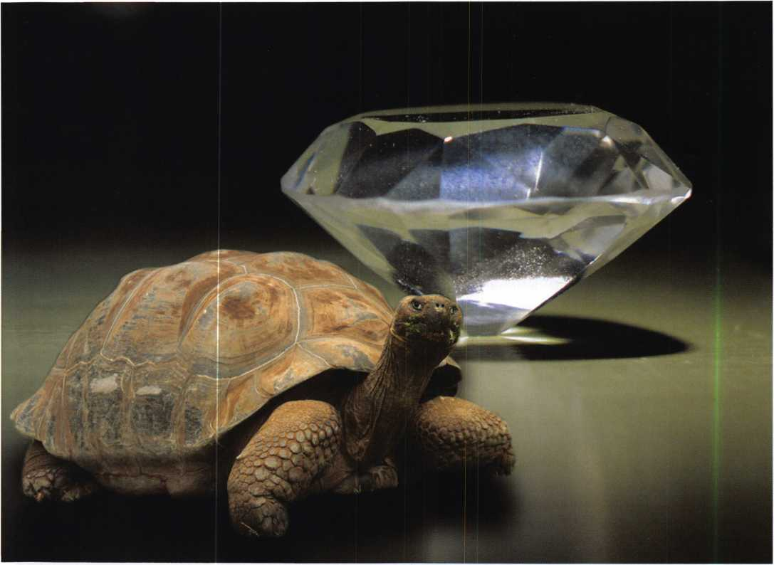

Diamond-core drilling is not the easiest process but, once mas­tered, it can be an excellent method of getting through carbide

included matrixes. Slow and Steady wins.

Keynotes • October 2004

No, its not time to buy some for your wife; were talking industrial-grade diamond-core drills. This article is prima­rily a primer on diamond-core drilling with a little infor­mation about drilling other hardplates. We’ll be using some of the new bits from StrongArm who have redesigned their diamond-core drill to make a great product even better. According to Jeff Voolsing the new core drill will cut softer materials better without clogging. “But wait! Aren’t diamond core drills for drilling carbide included hardplate not soft materials?”, I hear a few of you asking. The answer lies in the process of both creating and drilling carbide-included matrix hardplates. We’ll be look­ing at the reason for this later in the article.

Safe manufacturers, with the goal of keeping burglars out, have incorporated a number of different materials and ideas. In the process they also make it more difficult for us good guys to do our job. Many different types of hardplate have been manufactured. These include hardened steel, ceramic materials, ball bearings and carbide-included matrixes. Perhaps the most common carbide-included hardplates are found in Red Label GSA security containers produced by Hamilton, Overly, and Mosler/Diebold.

Other manufactures like Gary, Armor, Adesco and others have used carbide-included hardplates in some of their higher-end commercial safes. Hardened steel can typically be drilled with a carbide bit and a lot of pressure. Often times different hardplates require different drill speeds and pressure. Sometimes, a different cutting angle on the drill bit will create a better cutting bit. Most find the only way to truly learn how to drill hardplate is on the job. If one method is not working, try a different speed or pressure. Ceramic materials require punching with a sharpened punch. Ball bearings are best drilled with a carbide-end mill like the Ball-buster from StrongArm. StrongArm includes more than just an end mill. They include a special plug material to stabilize the bearings. That leaves the carbide-included matrixes. So how do we drill them? Some of you may ask, “why not use a carbide bit?”.

Trying to drill carbide with carbide is a no-win situation. The drill bit must be harder than the material being drilled or the bit will dull and not cut. A few different methods have been employed to drill or burn through carbide- included matrixes.

First method is to drill and punch. This method uses lots of bits, is time consuming and abusive on the body. Start by drilling into the hardplate until the bit dulls or breaks

the carbide off the end of the bit. Next sharpen a round punch to an edge like a cold chisel. Hold the punch in a pair of locking pliers and pound the punch into the hard­plate. The goal is to either break the carbide into small pieces or move it out of the way of the drill bit. Next start the process of drill and punch over again until you’re through the hardplate, hours later. The second method I’ll cover is not even a drilling method. It involves using a burning bar or thermal lance. This method became popu­lar in late 1980’s for a very short time. The hardplate, being so difficult to drill and punch, that some decided to try burning their way in. The downside to using a burning bar is that it can’t be used in most buildings. It’s messy and if you’re not careful you can burn the contents of the safe. If the lock has a thermal relock it may fire, requiring a sec­ond hole to be drilled.

Diamond-core drilling is currently the best method to drill carbide-included matrixes. Before drilling, we must first understand a little bit about the process of creating a car­bide-included matrix hardplate. Most manufacturers keep the exact process a secret. The general method is to either add the carbide by rolling it in while the steel is still hot or add it as the steel is being produced. (Visulaize adding chocolate chips to cookie dough.) This method will ran­domly pace the carbide in the plate. I’ve drilled some plates that seem to have no carbide in my way and others that seemed to have only carbide in my way. This is the reason there are both hard and soft materials to use when drilling through a carbide-included matrix. The other method I’ve seen is to use carbide-included welding rod to deposit the carbide on the surface of a plate.

So how do I drill carbide-included hardplate with a dia­mond-core drill? Asking the question in the first person is important, since my method is not the only method.

Diamond-core drills look like hole saws with diamonds instead of teeth. I developed this method after talking with Jeff and Bob Voolsing from StrongArm. They recommend­ed a few things. First, clean or polish the surface with a carbide bit. Second, use an inexpensive drill with an easy way to control the speed. Inexpensive drill motors are typi­cally not high-powered drills. This is important so the drill motor will slow under pressure. Third, start slowly. Fourth, use light pressure on the bit. Although I’ve heard of techni­cians using a lever rig with a diamond-core drill, a fixed rig like the Bullet Rig from Lockmasters, the StrongArm

**25**

Keynotes • October 2004

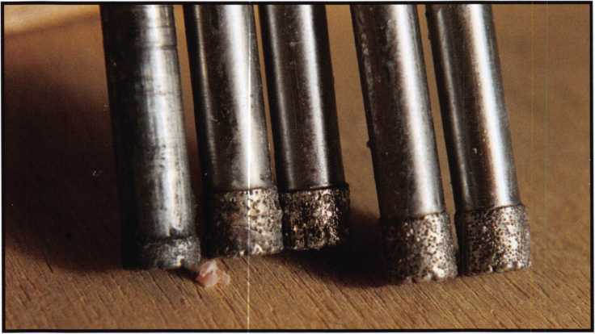

Photos 1 and 2 are the ends of  
five different StrongArm diamond  
core drills. The one on the left is  
a very old style bit, it has a short  
diamond sleeve around the tip.  
The middle bit is the newest bit. It  
has the deepest slot or relief  
between the diamonds. The other  
three are the middle vintage bits.

MiniRig or a magnetic-base press is required to use a diamond core drill. Let me take you through the process I use. First, I drill through the outer skin of the safe with a drill bit 1/32” larger in diameter than the diamond hole size for clearance. IVe measured a 1/4” diamond core drill as large as .280 thousands. Next, using a high power drill to power the drill rig, I typically use a 1/4” x 6” carbide bit to attempt to drill the hardplate. If it drills I keep going.

I use a 6” carbide bit, since the standard diamond-core drill from StrongArm is also 6”. Longer bits are available but they should only be used when drilling a very thick door. Usually I make some progress until I hit the first chunk of carbide. Sometimes the bit will snag and break the tip off. Other times the drill will either pause or stop momentarily or the drill will speed up indicating a lack of cutting. Inspect the hole. Often, you will see either a shiny spot in the center or a void area next to a piece of carbide.

Its now time for the diamond-core drill. After chucking the core drill in the drill rig and reattaching the drill rig to the base plate, I slowly feed the bit into the hole without the drill motor. Once the bit contacts the surface, I back the bit off slightly and attach the drill motor. I start the drill motor; just barely turning maybe 50 to 100-rpm as I slowly feed the bit into the surface. The idea is to avoid stripping the diamonds off the end of the bit. If you go too fast or apply too much force, the diamonds will strip off or fracture. The bit can also mushroom if you use too much force. If the carbide bit has cut into the hardplate, the core drill tip may try and conform to the slope or angle left by the carbide bit if you apply too much force. I slowly feed the bit into the material, perhaps taking two to four min­utes to advance the MiniRig feed screw one turn. After two

full turns of the feed screw, I slowly increase the speed of the drill motor as I continue to feed the bit into the material. Once I feel like the surface is smooth and flat,

I increase the speed of the drill motor to between 1000 and 1500-rpm. I also increase the feed rate. My rhythm is usually to turn the feed screw about 1 /8th of a turn, remove my hand and swing it down to my knee. Do this and the drill motor will slow down a little. Next, as the core drill cuts or grinds a little material away, the drill motor will speed up. This is when I swing my hand up to turn the feed screw another 1 /8th of a turn. Some will advise you to cut for around 5 minutes then remove the core drill, check the progress and re-lube the bit with the included wax before drilling with the diamond some more. I prefer to continue cutting until something changes. Usually the bit will clog with the softer steel from around the carbide. The drill will stop cutting; you can tell this by the sound of the drill motor. It will not increase in speed after cutting for a while. The new bits from StrongArm have deeper groves between the diamonds. StrongArm claims these bits will not clog with the softer metal as easi­ly as the prior versions. IVe tried them on a Mosler red label GSA container and found them to live up to the claim. Sometimes the bit may grab and stop or pause.

If this occurs you may lose the bit.

After removing the core drill, I use a wire brush to clean the end between the diamonds and then re-lube the bit with the wax lubricant. Next I usually switch back to a carbide bit and clean the plug left by the core drill in the middle of the hole. Sometimes the carbide drill will start cutting. If it does, keep drilling. If not, change back to the diamond core drill. Others have suggested using a punch



Keynotes • October 2004

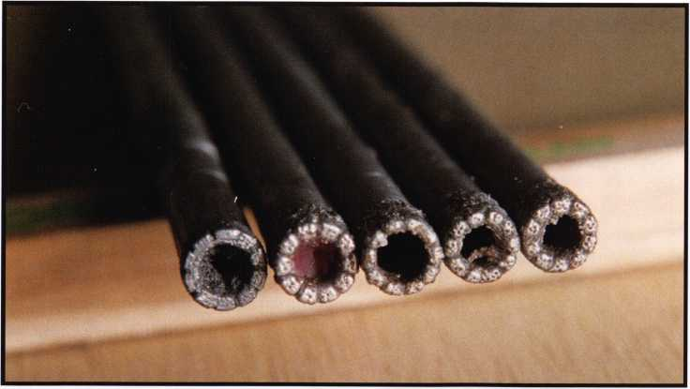

to remove the plug. I prefer using the carbide-drill method. When the carbide drill stops making progress its time to switch back to the diamond. Again use a very slow drill speed and light pressure to start. Repeat the process until you£re through the hardplate.

A different method I’ve heard of, but never felt comfort­able with, is to drill all the way through the hardplate with the diamond core drill leaving the plug intact. As you get to the very end, apply extra pressure to the core drill. This causes the bit to grab the plug and remove it as it snaps off. There are two problems I have with this method. Firs is

Diamond-core drilling is not  
the easiest process but once  
mastered it is an excellent  
method of getting through

carbide-included matrixes. The first time I drilled one, it  
took 6 hours and 3 diamond core drills. I’m now down  
to an average time of 45 minutes to 1 hour. I can usually  
drill about 1 safe plus make it halfway through a second  
hardplate before needing a second bit to finish the hole.  
There are still times when getting through a hardplate  
may take 2 hours but those times are usually far and  
few between. Remember the most important part in dia-  
mond-core drilling is to let the core drill work. Too much  
force will translate into many too many bits. Slow and  
steady wins.

the amount of friction that  
develops from the plug on  
the inner surface of the core  
drill. I find it better to  
remove the plug to decrease  
this friction. It provides a bet-  
ter feel for how the core drill  
is cutting. The second reason  
is that Mosler used two layers  
of hardplate on their red label  
containers. Using this  
method on a Mosler requires  
two diamond core drills.

Photo 3 is of the end of a bit after drilling. You can see the soft material  
clogged between the diamonds. This is the material you need to remove with

a wire brush.

Photo 4 shows the hole into the  
hardplate. The plug from the  
center of the bit can be seen  
in the picture.

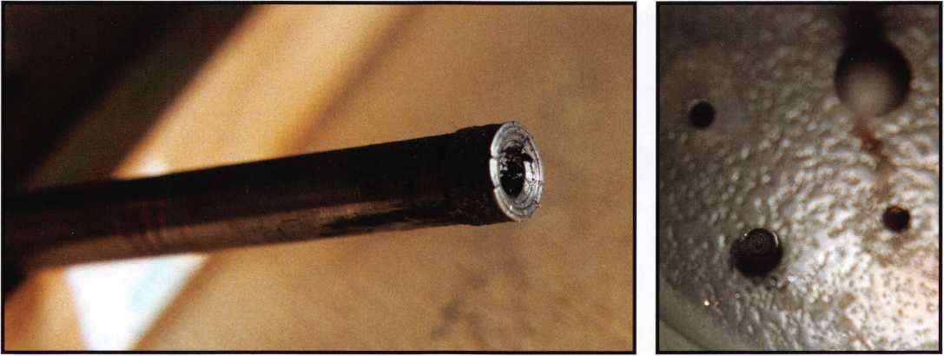

Keynotes • October 2004

**2**

The Kaba Mas X Series:

Hints and Suggestions

By Jorge R. Carmona III

We at Exolock Inc. have been doing  
business with the Federal  
Government in Puerto Rico for  
many years. My dad and I have  
been buying and installing X-07,

X-08 and X-09 locks since they  
were first released at facilities for  
the Federal Government. We con-  
sider ourselves experts.

When we first started installing the X-07,  
we encountered a couple of problems.  
One was the round spindle that,  
when secured to the dial hub  
assembly, tended to loosen itself.

Then came the round spindle with  
a flat surface to secure the two  
Allen screws of the dial hub assem-  
bly to the spindle. This was an  
improvement.

Another problem was at the other end of

the spindle, where it connects to the drive  
cam with an Allen screw (3/32”Xl”).

This was a weak connection, and after some use, it breaks off and you have a freewheeling dial.

A great improvement arrived with the X-08 and X-09 spindles. The drive cam is firmly secured by a stainless steel nut. The spindle is tri­angular in shape and fits into the trian­

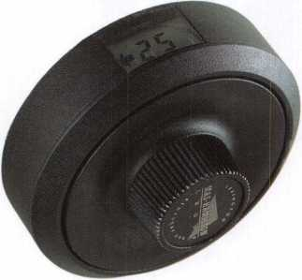

gular hole of the dial hub assembly, thus eliminating the chance for slippage. The same is true of the drive cam.

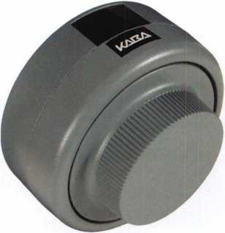

However, the X-08 was not without  
its problems, as well. The back cover  
pin can turn out to be a headache.

Its purpose is to avoid taking off the  
back cover, when locked in position.

In a few cases, you would not be able to

remove the back cover in the opened or  
closed position of the bolt. The main  
reason is because of a small, black flat-

head screw. Make sure you tighten  
this screw, because if if s not tight,  
the cover pin may get jammed in  
the groove.

The retaining ring on the dial hub  
assembly is something that needs  
improvement in all three locks. It is very  
weak, and bends out of shape easily. When

testing the lock before you install the dial,  
make sure you don’t touch this ring.

You may bend it out of shape. The  
last thing we do is install the dial,  
and if it does not click in, we have  
to order a new dial hub assembly.  
Make sure you perfectly align the  
retaining ring. Do not bang in the  
dial; align it in the dial ring and  
press in evenly with both thumbs.

**28**

Keynotes • October 2004

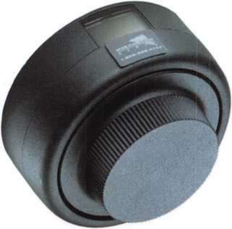

Some Helpful Hints:

Don’t install any of these locks if you don’t receive a sealed box, or if you haven’t furnished the lock yourself.

Ground yourself before you start the installation. We even carry a rubber mat.

Make sure you keep your hands dry and clean.

The alignment of the lock case assembly with the dial ring assembly (X-07) must be perfect. This will prevent mal­function. The plastic gears in the back cover must fit even­ly in the cam drive.

When installing plastic cables, use a round toothpick to help with the routing of the cables.

The *selling.*, installing repairing and neutralizing of these locks have been a great source of work for our company.

To do Federal jobs, you should be certified. If you are not, find out how to become certified.

If by any chance, the dial ring becomes loose, you can remove the back cover - remove the screw (X-07) or nut (X-08 and X-09), remove the dial with spindle, tighten the dial ring screws, and replace parts.

If the spindle will not go through the cam drive, you may have to file it down.

Always make sure the small, black flathead screw that secures the bolt is tight (X-08). Only use the parts and screws that come with the lock. If you switch out or modi­fy the parts, you are looking for trouble! We have had to respond to lockouts due to modifications done by inexperi­enced or unauthorized installers.

Last but not least, after installing a Kaba Mas lock and making sure the combination is working properly (50-25- 50), give the customer the operating instructions with the factory combination and the change key. Make sure the customer opens the lock three times to insure that it is

working correctly. Urge them to do the same once they change the lock to a new combination.

Final Comments:

Every time we ran into some sort of trouble with the X-07, we would call Mas Hamilton to ask for advice. The answer we would usually get was that they were not even sure what the answer was. In other words, they were solving the lock problems as encountered them. Therefore, over time, the X- 07 went through a series of modifications. In our opinion, when the X-07 was at its best moment, out came the X-08. We are not complaining, because this brought a lot of new work our way. Once again, when we had everything down on the X-08, there came the X-09. The X-09, in our opin­ion, is another revised version of the X-07, and a very good one at that. The selling, installing, repairing and neutraliz­ing of these locks have been a great source of work for our company. We have yet to see a troubleshooting manual for these locks from the Kaba Mas Corporation.

One of the features of these locks is the ability to audit them in order to know if there were any illegal attempts to open the safe, and if so, how many. In our experience in dealing with these locks, and with the Federal Government, we have noticed that no one really seems to use this feature, and in many cases, don’t even know that it exists.

Since these are electronic locks, sometimes you might run into some small problems (that have solutions). For exam­ple, we have had some locks come with a faulty stepper motor (retracts the bolt) straight out of the box, and the government agency has been able to replace this part direct from the factory. Some government agencies buy and store these locks in quantities over a period of time, so it is important that they are stored properly. To avoid misun­derstandings, we recommend once again that if you are to install any of these locks, make sure it is a sealed box, or that your furnish the lock yourselves.

**29**

Keynotes • October 2004

the mystery of the



ALOA APPARITION



**_ nm mere m moras spoRen**

)j) an cmplogec at the National ALO Headquarters in Dallas when she wa >hown a picture of a mysterious, blui :y, ghostly figure. Yes, you heard it :orrectly. Ghost. For many years no :here have been vague rumors of strange encounters, and obscure talej :>f things going bump in the night (a veil as in the day). But never before lave we had a definitive sighting or such an up-close encounter with the \LOA Apparition. Let us take a trip lack in time, and find out just how his “close encounter” came to be...

mas a dark and storing morning around 7 AM. Sue

came in to the ALOA office, expecting her normal routine. She strolled in casually, punched her time card - and headed back to her office to begin her day. Sue was normally a happy-go- lucky sort of person, not paying much attention to things around her. But something about this day was different. She couldn’t quite put her finger on it. Sue decided to brush it off and try to work as she always did. However, after a few pecks on her keyboard a cold chill came over her, as if something was watching her closely; and this time it wasn’t her boss.

She spun her chair around and there he was—an unnatural figure standing in the doorway. The figure was somewhat fuzzy and lacked any sort of definitive shape. (No, really. It wasn’t her boss). After the initial shock, Sue noticed that the figure fol­lowed the form of a man. He was a scruffy-looking sort with salt-and-pepper hair (Again, not her boss. Please, don’t ask again). Although most in this situation would be running for the door about then, Sue remained calm and unafraid. She could tell that this visitor meant her no harm. She tried to speak but, following the traditional ghost M.O., within a matter of seconds he vanished into thin air.

Sound far-fetched? Sound unrealistic? Sound like Sue had one too many Jelly Belly jelly beans for breakfast? Well, perhaps the last phrase is true. But the existence of the ALOA Apparition gains a little more credibility as the story moves on.

you Dare!

The next dag, jSuc returned to the office in the usual manner. She

punched the clock, turned on the light and began her daily routine once again. She needed to work on a particular credit card statement for her boss. She had placed it in her “to do” box the previous day. But as she reached for it she noticed... (insert dramatic pause)

IT WAS GONE!

How could this be? No one had been in the office but her. This inexplicable disappearance caused her to take a quick inventory of her desk. Sure enough, there were more things missing. She noticed a pencil was gone.

She noticed a sheet in her notebook was missing. Here a pen, there a pen, everywhere a pen-pen. What was going on? And then she saw it!

DUM DUM da DUM!!! (Um, that was the over-dramatic music).

Kevin was the first one chosen. He had a knack for tracking packages like nobody’s business. The team figured he would be indespensible for tracking down this ghost.

A note was left on her desk. It read: “I took yor pencil. HA HA.”  
So not only was this mysterious man a thief. He also had

deplorable grammatical skills.

This was worse than she

thought. He must be

stopped.

Suddenly, a fear  
spread through-  
out the office.

More things

were missing.

Kathy was miss-

ing expense reports.

Kevin was missing some

boxes. Mary was missing her assistant! The entire  
office came together and concocted a plan. A secret ;

team was formed to investigate these strange hap-  
penings and to track down this ghost fellow.

I

Betty was the second team member. Her drawings of bunnies made her an excellent pick to create a forensic drawing of the ghost as Sue supplied the description.

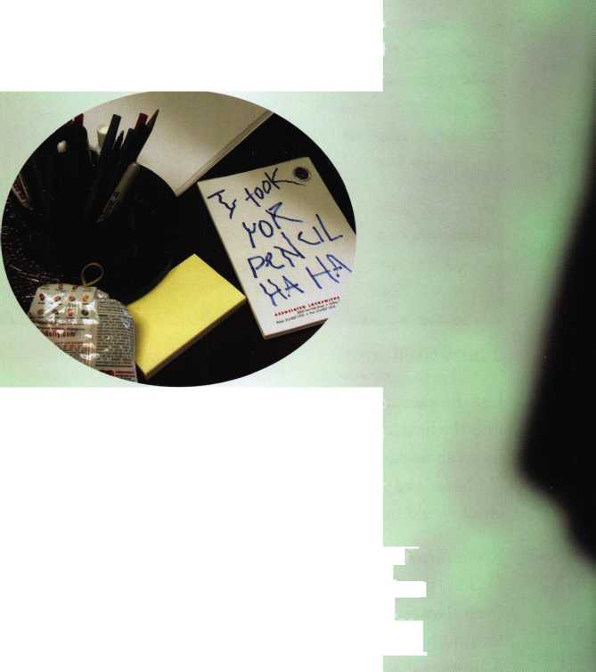

THE LOCKSMITH

*GHOST FOUND IN WAREHOUSE*

Bryan was the last to be chosen. He claimed to have seen Ghostbusters 32 times and assured everyone that “he ain’t afraid of no ghost!”

The apparition team (or A-team as they like to be called) immediately went to work. The goal was to look for more puzzling office occurrences in order to track down the ghost. This did not take very long. A quick trip to the rest­room revealed that the water pressure there had completely been lost. What kind of cruel joke was this ghost playing? Then, another call came in. It seemed that Kathy’s office had a particular leak in the roof that continually leaked in the same place but mysteriously stopped leaking when the roofers came to inspect it. It was as if the ghost was undo­ing the patchwork on purpose. The hunt quickly led the team to the Publications Department, where one of the advertisements for the magazine was said to have been bleeding! (Luckily, the A-Team found out that “bleed” was a technical term for colors going past the edge of a page.) But alas, the team had made mistakes. (Doesn’t every ghost story have to say “alas” at least once?) They lost the trail.

Finally, the A-team got a breakthrough. Even though the ghost was no threat to humans, he was apparently leaving a trail of dead bugs behind. Dead bugs were everywhere!

Bugs were dropping like flies! (Hmm, okay. Maybe that was a little redundant.) Eventually, this trail of destruction led the team straight into the warehouse.

The Warehouse.

Just the mention of that name brought a twinge of fear into the hearts of those about to enter. The A-Team had heard about how spooky it could be in there with all the old boxes and dust. But they decided that confronting a ghost would be worth conquering their fears.

Kevin turned the knob but the lock was stuck.

Luckily, the ALOA staff knew where to find a locksmith (<http://www.aloa.org/locksearch.cfm>). The ALOA-certified locksmith made quick work of the door and soon the A-Team had access. They slowly pushed the door open. Creeeeeeeeeak. One by one they entered the cardboard tomb. Betty quickly hit the lights. Nothing happened.

The only things the group saw were boxes and an old fork­lift. But they knew the ghost HAD to be in here. All roads led to the warehouse. They decided to split up in order to cover more ground. All of a sudden, Kevin yelled out,

The warehouse is a scary place to be during the  
night. It's an excellent dwelling for a ghost...

EERIE IMAGE

CAPTURED ON FILM!

i

Detailed Proof!



Keynotes • October 2004

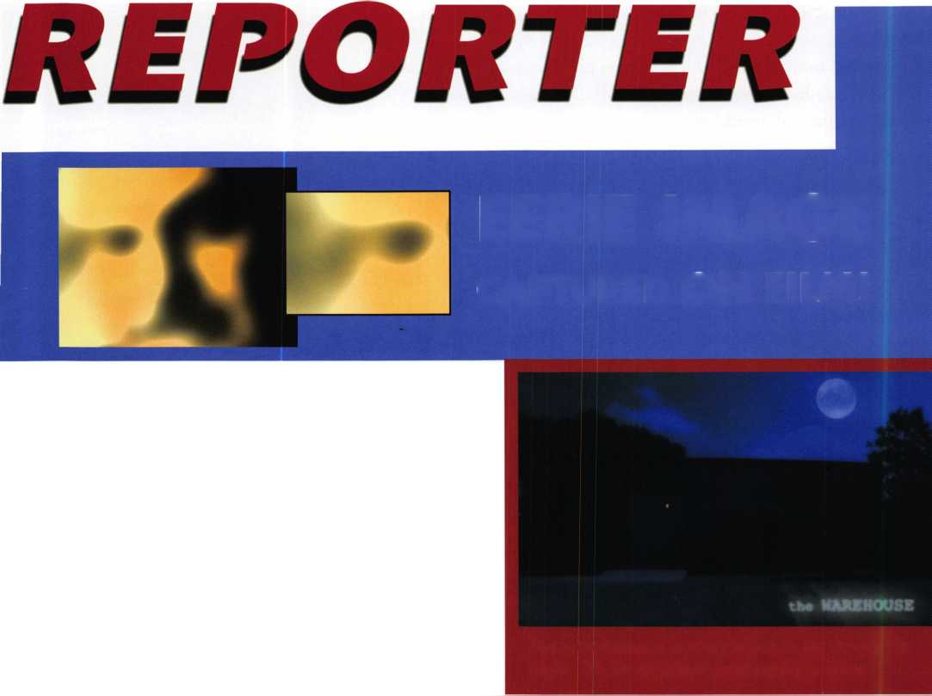

“I’ve found something!” The rest of the team ran over to see the discovery. To their surprise it was a stash of ink pens and highlighters! Sue exclaimed, “Those are all mine!” They were in the right place after all. Betty also had made an incredible discovery. Hidden underneath some old Keynotes magazines were several strange-looking machines. The team came to the conclusion that these machines must have been used to torture and destroy bugs, creating the trail that led them to this point. Then Bryan said, “Cant ghosts fly, or levitate, or at least jump really high?” And the team knew he was on to something. They began looking up and found the hard evidence they needed to prove that the warehouse WAS “Ghost Central”. A single footprint rested on one of the warehouse rafters. Mr. Ghost had gotten sloppy. Having lived in the warehouse, he should have remembered how dusty the floor was. He had given himself away.

At that point, Kevin yelled out, “Show yourself ghostie!” Suddenly the room was filled with an eerie green light. Screeching noises echoed throughout the entire warehouse. Dark clouds of dense smoke began to fill the inside of the cave-like structure. The team could hardly breathe (really, it was no different than during the smokers’ morning break!) They peered through the smoke and wondered if David might have just been cleaning again. But suddenly the ghost appeared out of thin air to make his grand entrance.

“How did you guys know how I was doing all of this?” he asked. “And how did you know where to find me? I have failed the ghost profession.”, he howled. Betty was the first to speak up and remind the ghost that too many strange things were happening around the office for human hands to be at work. Besides, she and Sue understood the super­natural. Sue piped in and told the ghost that she had seen him in her office. Kevin told the ghost that the team had tracked him with the bug trail, ink pen stash and foot­prints on the ceiling. Bryan was the last to speak up, and told the ghost “We knew you weren’t human. You took pencils from Sue’s desk, and left Jelly Bellies sitting there. No real person would do that!”

The ghost then agreed to return all that he had stolen, to leave the roof alone, to give back the expense reports and to stop coming in to the offices uninvited. The team agreed to let the ghost to remain in the warehouse as long as he continued to take care of the bugs.

And they all lived happily ever after... (because it was Halloween, after all. bwwwwaaaaahahahaha!)

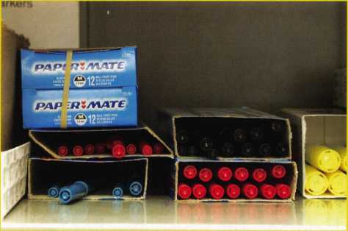

UNREAL!

This ghost just seems to take  
whatever he wants!

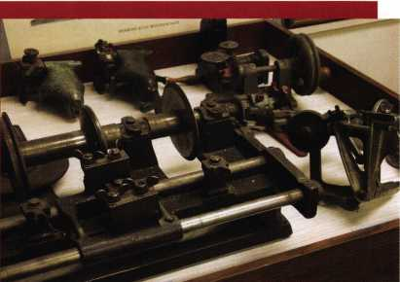

Look out all you creepy-crawly creatures! This ghost apparent­ly has a knack for making quick work of the likes of you!

**BUGS ON THE RUN!**

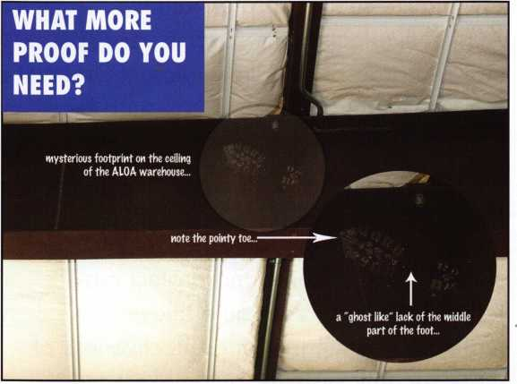

Keynotes • October 2004



Arlington, VA - The National Automotive Service Task Force (NASTF) announced today that a new NASTF Vehicle Security Committee has been formed to address recent issues raised by automotive security professionals.

The decision was made to establish the new committee after a working group of locksmith and automaker representatives met in May and July. The co-chairmen of the new committee are Paul Kanitra, gov­ernment relations manager of the Associated Locksmiths of America, and Mark SaXonberg, manager of service technology for Toyota Motor Sales USA.

The immediate focus of the new commit­tee is to identify and address gaps in access to vehicle security information for automotive security professionals. Automotive locksmiths cover a very spe­cialized area of vehicle service, includ­ing the opening of locked cars and the making of replacement keys. Over the past several years, most automakers have introduced sophisticated vehicle security systems to meet strict vehicle security requirements and protect cus­tomers' property from auto thieves. To maintain the integrity and effectiveness of these security systems, automakers must

limit access to information required to perform these unique services for cus­tomers.

The committee is currently exploring methods to develop a secure information release model that would establish a national registry of automotive security professionals. Conceptually, Internet and mobile telephone technologies could be used to validate information requests involving security related data. The com­mittee's current objective is to establish a model that can ultimately be developed in a cooperative effort among automotive security professionals, automakers, insur­ance companies, and law enforcement agencies.

The National Automotive Service Task Force was established in 2000 to facili­tate: (1) the identification and correction of gaps in the availability and accessibil­ity of OEM automotive service informa­tion; (2) technology training for techni­cians; (3) availability of both OEM and generic diagnostic tools and equipment; and (4) communication outreach to auto­motive service professionals. Go to [www.nastf.org](http://www.nastf.org) for details.

**34**

Keynotes • October 2004

LEGISLATIVE  
ACTION NETWORK

You’re a professional locksmith,  
not a professional lobbyist.

You can’t be on the steps of every state capitol and walking the halls of the federal government to protect your profession, but...

The ALOA Legislative Action Network is constantly working to influence legislation that’s important to the locksmithing pro­fession. We are working in your best interests to promote legislation that will have a positive impact on our proud profes­sion; while preventing or limiting legislative efforts that are harmful. To continue, we need your help to ensure the success of our legislative program for 2004!

If you contribute $25-$99.99 to the Legislative Action Fund, you automatically become a member of the Legislative Action Network (LAN). The LAN is an important tool in raising the standards of our profession through the legislative process by making sure that locksmiths have the final say in how our industry will be run. As a LAN member, you will receive:

* The Legislative Action Network Update alerting you to important legislation in your state and around the country.
* Networking opportunities with ALOA members who share the belief that legislative involvement is important to the effec­tiveness of our association.
* A listing of your state representatives and senators including capital and district addresses, and phone and fax numbers on both hard copy and disk.
* A comprehensive guide to lobbying in your state capital, so you can be the "voice of ALOA" to legislators.
* LAN stationary and envelopes for sending official letters to legislators, lobbying on ALOA’s behalf.
* A lapel pin designating you as a special ALOA LAN member,
* Recognition in Keynotes magazine.
* An invitation to an exclusive reception at the annual ALOA convention for LAN members.

When you donate $100 or more, you become part of the heart of the legislative program through LAN membership and receive the following:

* A reserved place of distinction on the special LAN Council
* Discounts on ALOA bookstore items and a 10 % rebate on all ACE classes.
* Complimentary Legislative Convention merchandise.
* It’s easy to do Your part...just join TODAY!!

NOTE: Contributions or gifts to the Associated Locksmiths of America, Inc. are not tax deductible as charitable contribu­tions or as business expenses under IRC - 162(e).

WE CAN!

The ALOA Legislative Action Network (LAN) needs Your support for the Voice of Our Profession.



SAFE CORPORATION

MANUFACTURES OF QUALITY DEPOSITORY SAFES AND CHESTS

DISTRIBUTING FROM A & B is now a stocking distributor We ship yc WAREHOUSES IN for Mutual Safes 24

WAREHOUSES IN

featuring

r Mutual Safes  
during



We ship your order within

24 hours

See us

* LOS ANGLES**,** CA
* CHICAGO**,** IL
* GLASSBORO, NJ

at [www.a-bsafecorp.com](http://www.a-bsafecorp.com)

800-253-1267  
Fax 856-863-1208

CALL FOR YOUR  
CATALOG TODAY

AB-4-30-3S AB-9-2 WS 10-2

Chose from over 75 models in stock

Keynotes • October 2004



Classifieds



EMPLOYMENT

LOCKSMITH WANTED

Busy shop in Woburn, MA is looking for experienced locksmiths to join our team. If you're a self-motivated hard worker willing to work reasonable hours and be compensated for your abilities, this is for you. We have a large client base for commercial, residential, safes, door and glass storefronts and automotive customers including 2 AAA contracts. Please call John for more information at 781-933-9999 or send resume to: Locks & Keys Inc., P.O. Box 222 • Woburn, MA 01801 (all inquiries kept strictly confidential)

FULL TIME SENIOR LOCKSMITH

Full time senior locksmith needed for fast growing Bank Security Company in Eastern Pennsylvania. Responsibilities include serv­ice and maintenance of vaults, safes, time locks, safe deposit boxes, teller lockers, and after hours depositories. No automo­bile or residential lock work involved. Geographic area covers eastern PA and all of NJ and DE with Company-provided lock van. Benefits include competitive pay rates, 401K, healthcare, and flexible work environment. Send resume and salary requirements to [Jobs@GilbertsonGroup.com](mailto:Jobs@GilbertsonGroup.com) or fax them to 610-466-9019.

MECHANICAL SALESMAN DESIRED!

Bass Security Services, Inc. is looking for a Mechanical Salesman to fill a position in the Sales Department of our Cleveland Ohio office. The ideal candidate must possess excep­tional communication skills and 2-3 years of mechanical sales experience. For more information call 800-523-1422 x. 157 or fax a resume to 888-774-8900 or e-mail [sales@bass-security.com](mailto:sales@bass-security.com)

EXPERIENCED LOCKSMITH WANTED

Charlottesville, VA is seeking an experienced locskmith. For infor­mation please email [snowderrow@aol.com](mailto:snowderrow@aol.com) or fax resume to 434-971-8021.

SECURITY TECHNICIANS

Looking for experienced, motivated, hardworking technicians and team players. Great income potential. Don't delay and send resume today.

Liberty Lock & Safe

5470 W Sahara Ave Las Vegas, NV 89146 Fax 702-876-5470 or [www.libertylock.com](http://www.libertylock.com)

EXPERIENCED LOCKSMITH WANTED

Experienced Locksmith Wanted for permanent position with 30- year-old company, located on "The Main Line", in the beautiful suburbs of Philadelphia. Commercial, residential, some electron­ics. Excellent pay and benefits. Truck, tools, and uniforms provid­ed. Requires neat appearance, good people skills, clean record, and drug free, able to lift up to 100 pounds. Please fax your resume to Dayton Lock Co. 610-975-0172, or email [ntdayton@icdc.com](mailto:ntdayton@icdc.com).

LOCKSMITH WANTED

Immidiate opening for a full-service locksmith. Commercial and residential. No auto work! Pay and benefits relative to your experience and ability. Monday-Friday operation. Contact Michael Beattie at Professional Lock $ Safe Co. 1575 Main St, Williamantic, CT 06226. 860-423-5513 or 860-742-6386.

Fax resume to 860-423-5604.

EXPERIENCED LOCKSMITH

Established and expanding company in central NJ is seeking experienced help in residential/commercial/auto/access con­trol/safe work. Top pay for top mechanics along with medial, dental, paid vation, no night calls. Apple Locksmith. 4030 Route 9 South, Morganville, NJ 07751.732-970-1500 or fax resume to 732-970-9725. Attn. Andy or Jack.

HELP WANTED

Argens Incorporated, a full service security company, is expand­ing. We are looking to add experienced, personable people in all aspects of our company. Inside and outside positions are available. If you have locksmithing or electronic security experi­ence and want to live in the Pacific Northwest, please email [stevet@argens.com](mailto:stevet@argens.com). All positions are full time with a good wage, health insurance, retirement plan, holidays and generous vaca­tion pay.

**4R** SECURITY GROUP, INC.

A&B Security Group is a well established, fast growing locksmith security company in Las Vegas. We are looking for the right indi­viduals to grow with us and become part of the future. If you are looking for a future, not just a job, then we want you!

* Medical Benefits
* 401K Program with Matching Dollars
* Paid Vacation
* Good Work Environment
* Advancement
* Established Company

For a confidential interview, call Gary of Phil - 702-362-0222

LOCKSMITH WANTED

Immediate opening at one of Columbus Ohio's largest locksmith companies. If you are a locksmith with three years of commercial experience and want to work 8:30 to 5:00, come join our team! We are a full service security center. Excellent benefits include 401K, health insurance, paid vacation, sick leave, and continu­ing education. Contact Bill or Tim at Golden Bear Lock & Safe, Inc. 614-733-5625, fax 614-733-0004, or email [goldenbearlock@cs.com](mailto:goldenbearlock@cs.com).

EXPERIENCED LOCKSMITHS

Nationwide company needs F/T, P/T independent contractors throughout the U.S.: Nashville/Knoxville, Mobile, Atlanta, New Orleans, Dallas/Houston/San Antonio, Little Rock, Conn., Mass., Rl, NY and Oklahoma. $1500 - $2500 wk. Full Service Ability or "Nite-Owls" a PLUS ie: auto/residn'I/comm-lockout/rekey, etc. MUST have your own vehicle/tools. Please call Paul (617) 921-2758.

WANTED TO BUY/SELL

WHOLESALE SAFE DEPOSIT LOCKS

Allied, Diebold, Herrin, Hall & Mavin, llco, Lefabure, Mosler, Precision, S&G, Security Corp., and Yale. Locks from early 1900s to current. Call or email for lock type and pricing sheet. Quantity discounts. Call WBI at 954-484-2404 or email sales @wbi.us

IN-STOCK...MORE SAFES

***FREE Freight Program***

***(30 States)***

**MSEC RreKing BaeM** HAYMAN MEILINK y/CT0R

**TURPI lO**

**WHOLESALE SERVICE**

800-848-9790

.25+ Function

Multi-Tool

**—** Lifetime Warranty **—**

FOR LOCKSMITHS ONLY

► 25 Functions  
’ Services Schlage, Baldwin,

Corbin/Russwin, Lori,

Adams Rite, Master  
padlocks, Medeco, Arrow,

Jackson crossbars and

many morel

Cali Toll Free...

888-634-LOCK

[www.lockmantools.com](http://www.lockmantools.com)



EQUIPMENT FOR SALE

Framon #2 never used, HPC 1200 1 10&12 Volt with code cards, ILCO 017 like new with extra cover, HPC code books, Curtis Clipper with extra cams and carriages, MK! and MK2 Code Cutters and component parts, ILCO Speedex, Curtis Key Machine with double tower, Russin Pinning Kit, Corbin Pinning Kit, Kwikset/Titan Pinning Kit, GM-Ford-Chrysler Pinning Kit, Professional Universal Pinning Kit, Foley Belsaw Key Machine, Assorted Keys worth about 2000.00, Stamp ses letters and num­bers, EEZ Readers for 12 makes of vehicles, Rescon Set, 2 Cases for tools, various auto opening tools. 2500.00 Firm. Contact Howard J Perry.Franklin St Box 465, Hallstead PA, 1 8822-0465, 570-879-4476 or 570-879-2248.

WANTED TO BUY

Illinois licensed locksmith with 17 years experience is looking to purchase an existing small Locksmith business. Must be located in the Chicago area. Contact Mark at 630-428-4476.

FOR SALE

Due to retirement, will accept 10,000.00 cash for 13,400.00 worth of Machines, Tools and Equipment. Will provide inventory to interested parties. Inquire by fax to 863-682-9550 or email to [wemloxmith@aol.com](mailto:wemloxmith@aol.com).

FOR SALE

Convention souvenir collection. Many years and locations.

Write: 11315 Hall Drive, Nampa, Idaho 83651 or e-mail [meilan@yc2.net](mailto:meilan@yc2.net).

BUSINESS FOR SALE

FOR SALE

Colorado commercial locksmith business (est 1974) located in vibrant golden triangle, adjacent to downtown Denver. Includes vans, equipment, inventory, and loyal customer base. Building also available with additional rental income capacity. Serious inquiries: Mr Jones (agent) 1420 Jamaica St, Aurora, CO 80010-3498 Fax 303-573-9099

FOR SALE

Well established Lock Shop with AAA contract, 24 hour Mobile Van Service, Commercial, Residential and Turn-Key Auto Shop. No Pun intended! Owners will train and/or assist with the transi­tion of this busy shop with a great location on Highway 101 in the heart of Coos Bay, Oregon. Call Realty Solutions LLC: Ellie Cary 503-620-5533.

FOR SALE

Locksmith business for sale: 4 key machines: Framon Model 2, Framon Model DBM-1, HPC Trace-A-Key (manual) Model 3333, Rytan Key Machine Model 504831. Vast quantities of keys, lock- sets, key blanks, code books, and locksmith tools. Also a 1995 Chevy commercial van fitted for a mobile locksmith shop.

Richard Walther Estate •

Norma Walther, Executor •

2024 Garden Avenue Waverly,

Iowa 50677 • 318-352-2138

Classified Advertising Policy

Classified advertising space is provided free of charge to  
ALOA members and for a fee of $2.00 per word, $40.00  
minimum for non members. Classified ads may be used to  
advertise used merchandise and overstocked items for sale,  
"wanted to buy" items, business opportunities, employment  
opportunities/positions wanted and the like. Members or non  
members wishing to advertise services or new merchandise  
for sale may purchase a "Commercial Classified Ad" for a  
fee of $4.00 per word with a minimum of $100.00. Each ad  
will run for two issues. For blind boxes there is a $10.00  
charge for members and non members. All ads must be sub-  
mitted in writing to the Advertising Sales Department via fax  
at 817-645-7599 or through an email to [adsales@aloa.org](mailto:adsales@aloa.org)  
by the fifteenth of the month two months prior to issue date.  
ALOA reserves the right to refuse any classified advertisement  
that it deems inappropriate according to the stated purpose  
of the classified advertising section.



SAFE CORPORATION

**Viking Stainless**

Fire & Burglary Protection  
State of the Art Composite Fill

Strong • Functional • Attractive

Available in 10 sizes  
to Fit Every Need

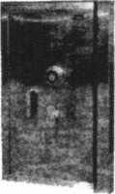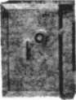

See us at [www.a-bsafecorp.com](http://www.a-bsafecorp.com)

1*-*800*-*253-1267

Fax 856-863-1208

CALL FOR YOUR CATALOG TODAY

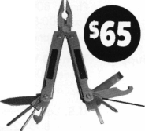

Distributor

**1st In Hardware, Inc.**

Phone: 866-397-9900 Fax: 866-646-0045 www. 1 stinhardware.com

**ADI Inc.**

Phone: 631-692-1000 Fax: 631-692-3011

**Accredited Lock Supply Co.**

Phone: 800-652-2835 Fax: 201-865-0030 [www.acclock.com](http://www.acclock.com)

**Ace Lock & Security Supply**

Phone: 800-223-5625 Fax: 908-688-2442 [www.acelock.com](http://www.acelock.com)

**Andrews Wholesale Lock Supply**

Phone: 717-272-7422 Fax: 717-274-8659 [www.andrewslock.com](http://www.andrewslock.com)

**Boyle & Chase Inc.**

Phone: 800-325-2530 Fax: 800-205-3500 [www.boyleandchase.com](http://www.boyleandchase.com)

**Chinrose International**

Phone: 503-357-7553 Fax: 503-357-5522 [www.chinrose.com](http://www.chinrose.com)

**Clark Security Products**

Phone: 888-784-1311 Fax: 619-718-7333 [www.clarksecurity.com](http://www.clarksecurity.com)

**Cook's Building Specialties**

Phone: 505-883-5701 Fax: 505-883-5704

**Dire's Lock & Key Company**

Phone: 303-294-0176 Fax: 303-294-0198

**Direct Security Supply, Inc.**

Phone: 800-252-5757 Fax: 800-452-8600

**Discount Key Machines.Com/Busch**

Phone: 800-332-8724 Fax: 407-363-4666

**Doyle Security Products**

Phone: 800-333-6953 Fax: 612-521-0166 [www.doylesecurity.com](http://www.doylesecurity.com)

**Dugmore and Duncan, Inc.**

Phone: 888-384-6673 Fax: 888-329-3846

**E. L. Reinhardt Co., Inc.**

Phone: 800-328-1311 Fax: 651-481-0166 [www.elreinhardt.com](http://www.elreinhardt.com)

**Ewert Wholesale Hardware**

Phone: 800-451-0200 Fax: 708-597-0881

**Fairway Supply, Inc.**

Phone: 214-350-0021 Fax: 214-352-4299 [www.fairwaysupply.com](http://www.fairwaysupply.com)

**Foley-Belsaw Company**

Phone: 800-821-3452 Fax: 816-483-5010 [www.foley-belsaw.com](http://www.foley-belsaw.com)

**Fried Brothers Inc.**

Phone: 800-523-2924 Fax: 215-592-1255 [www.fbisecurity.com](http://www.fbisecurity.com)

**Hans Johnsen Company**

Phone: 214-879-1550 Fax: 214-879-1530 [www.hjc.com](http://www.hjc.com)

**Hardware Agencies, Ltd.**

Phone: 416-462-1921 [www.hardwareagencies.com](http://www.hardwareagencies.com)

**IDN Incorporated**

Phone: 817-421-5470 Fax: 817-421-5468 [www.idn-inc.com](http://www.idn-inc.com)

**Intermountain Lock & Supply**

Phone: 800-453-5386 Fax: 801-485-7205 [www.intermountainlock.com](http://www.intermountainlock.com)

**Jo Van Distributors**

Phone: 416-752-7249 Fax: 416-752-7282 [www.jovanlock.com](http://www.jovanlock.com)

**Lockmasters, Inc.**

Phone: 859-885-6041 Fax: 859-885-7093 [www.lockmasters.com](http://www.lockmasters.com)

**Locks Company**

Phone: 800-288-0801 Fax: 305-949-3619

**Locksmith Ledger International**

Phone: 770-886-0800 Fax: 770-889-7703 [www.lledger.com](http://www.lledger.com)

**M. Zion Company**

Phone: 212-349-8677 Fax: 212-964-0495 [www.mzion.com](http://www.mzion.com)

**McDonald Dash Locksmith Supply**

Phone: 800-238-7541 Fax: 901-366-0005 [www.mcdonalddash.com](http://www.mcdonalddash.com)

**Monaco Lock Co.**

Phone: 800-526-6094 Fax: 800-845-5625 [www.monacolock.com](http://www.monacolock.com)

**Omaha Wholesale Hardware**

Phone: 800-238-4566 Fax: 402-444-1664 [www.omahawh.com](http://www.omahawh.com)

**RA-Lock Company**

Phone: 972-775-6301 Fax: 972-775-6316 [www.ralock.com](http://www.ralock.com)

**Security House**

Phone: 905-669-5300 Fax: 905-660-6313 [www.securityhouselock.com](http://www.securityhouselock.com)

**Security Lock Distributors**

Phone: 800-847-5625

Fax: 800-878-6400

[www.securitylockdistributors.com](http://www.securitylockdistributors.com)

**Shin-An Enterprise Inc.**

Phone: 718-225-5380 Fax: 718-819-0723

**Southern Lock and Supply Co.**

Phone: 727-541-5536 Fax: 727-544-8278 [www.southernlock.com](http://www.southernlock.com)

**Stone & Berg Wholesale**

Phone: 800-225-7405 Fax: 800-535-5625

**The Locksmith Store Inc.**

Phone: 847-364-5111 Fax: 847-364-5125 [www.locksmithstore.com](http://www.locksmithstore.com)



Keynotes • October 2004

**Timemaster Inc.**

Phone: 859-259-1878 Fax: 859-255-0298 [www.time-master.com](http://www.time-master.com)

**Top Notch Distributors, Inc.**

Phone: 800-233-4210 Fax: 800-854-4146 [www.topnotch.bz](http://www.topnotch.bz)

**Turn 10 Wholesale**

Phone: 800-848-9790 Fax: 800-391-4553

**U.S. Lock Corp.**

Phone: 800-925-5000 Fax: 800-338-5625 [www.uslock.com](http://www.uslock.com)

Manufacturer

**A & B Safe Corporation**

Phone: 800-253-1267 Fax: 856-863-1208 [www.a-bsafecorp.com](http://www.a-bsafecorp.com)

**ABUS Lock Company**

Phone: 800-352-2287 Fax: 602-516-9934 [www.abus.com](http://www.abus.com)

**Access Security Products Ltd.**

Phone: 905-337-7874 Fax: 905-337-7873 [www.access-safe.com](http://www.access-safe.com)

**Adams Rite Mfg Company**

Phone: 800-872-3267 Fax: 800-232-7329 [www.adamsrite.com](http://www.adamsrite.com)

**Adesco Safe Mfg. Company**

Phone: 800-694-9340 Fax: 562-408-6427 [www.adesco.com](http://www.adesco.com)

**Adrian Steel Company**

Phone: 800-677-2726 Fax: 517-265-5834 [www.adriansteel.com](http://www.adriansteel.com)

**All Five Tool Company, Inc.**

Phone: 860-583-1691 Fax: 860-583-4516 [www.all5tool.com](http://www.all5tool.com)

**associate**

**members**

**American Lock Company**

Phone: 708-534-2000 Fax: 708-534-0531 [www.armericanlock.com](http://www.armericanlock.com)

**American Security Products**

Phone: 909-685-9680X1083 Fax: 909-685-9685 [www.amsecusa.com](http://www.amsecusa.com)

**Best Metaline Inc.**

Phone: 714-441-0098 Fax: 714-441-0977

**Bianchi USA, Inc.**

Phone: 800-891-2118 Fax: 216-803-0202

**Buddy Products**

Phone: 800-886-8688 Fax: 312-733-8356 [www.buddyproducts.com](http://www.buddyproducts.com)

**CCL Security Products**

Phone: 800-733-8588 Fax: 847-537-1800

**COMPX Security Products**

Phone: 864-297-6655 Fax: 864-297-9987 [www.compxnet.com](http://www.compxnet.com)

**D&D Technologies (USA), Inc.**

Phone: 714-677-1300X292 Fax: 714-677-1299 [www.ddtechusa.com](http://www.ddtechusa.com)

**DETEX Corp.**

Phone: 800-729-3839 Fax: 830-620-6711 [www.detex.com](http://www.detex.com)

**DORMA Architectural Hardware**

Phone: 717-336-3881 Fax: 717-336-2106 [www.dorma-usa.com](http://www.dorma-usa.com)

**Datakey Electronics**

Phone: 952-746-4066 Fax: 866-289-4212 [www.datakeyelectronics.com](http://www.datakeyelectronics.com)

**Don-Jo Manufacturing, Inc.**

Phone: 978-422-3213 Fax: 978-422-3467 [www.don-jo.com](http://www.don-jo.com)

**Door Controls International**

Phone: 800-742-3634 Fax: 800-742-0410 [www.doorcontrols.com](http://www.doorcontrols.com)

**ESP Lock Products Inc.**

Phone: 800-434-8960 Fax: 978-562-9859

**FireKing Security Products**

Phone: 800-457-2424 Fax: 800-896-6606 [www.fkisecuritygroup.com](http://www.fkisecuritygroup.com)

**Framon Manufacturing Company Inc.**

Phone: 989-354-5623 Fax: 989-354-4238 [www.framon.com](http://www.framon.com)

**HPC, Inc.**

Phone: 847-671-6280 Fax: 847-671-6343 [www.hpcworld.com](http://www.hpcworld.com)

**HY-KO Products Co.**

Phone: 330-467-7446 Fax: 330-467-7442

**Hammerhead Industries, Inc.**

Phone: 805-658-9922 Fax: 805-658-8833 [www.gearkeeper.com](http://www.gearkeeper.com)

**Ingersoll Rand SSA**

Phone: 317-613-8025 Fax: 317-613-8068 [www.schlagelock.com](http://www.schlagelock.com)

**Jet Hardware Mfg., Co.**

Phone: 718-257-9600 Fax: 71 8-257-0973 [www.jetkeys.com](http://www.jetkeys.com)

**KABA ILCO Corp.**

Phone: 252-446-3321 Fax: 252-446-4702 [www.kaba-ilco.com](http://www.kaba-ilco.com)

**KEY-BAK/West Coast Chain Mfg.**

Phone: 909-923-7800 Fax: 909-923-0024 [www.keybak.com](http://www.keybak.com)

**Keri Systems Inc.**

Phone: 408-451-2520 Fax: 408-441-0309 [www.kerisys.com](http://www.kerisys.com)

**Knaack Manufacturing Co.**

Phone: 800-456-7865 Fax: 815-459-9097 [www.weatherguard.com](http://www.weatherguard.com)

**LAB Security**

Phone: 800-243-8242 Fax: 860-583-7838 [www.labpins.com](http://www.labpins.com)

**La Gard Inc.**

Phone: 310-325-5670 Fax: 310-325-5615 [www.lagard.com](http://www.lagard.com)

**Lock America, Inc. dba L.A.I. Group**

Phone: 714-373-2993 Fax: 714-373-2998 [www.laigroup.com](http://www.laigroup.com)

**Lucky Line Products, Inc.**

Phone: 858-549-6699 Fax: 858-549-3241 [www.luckyline.com](http://www.luckyline.com)

**M.A.G. Security**

Phone: 714-891-5100 Fax: 714-892-6845 [www.magsecurity.com](http://www.magsecurity.com)

**MUL-T-LOCK USA, Inc.**

Phone: 800-562-3511 Fax: 973-778-4007 [www.mul-t-lock.com](http://www.mul-t-lock.com)

**Medeco Security Locks**

Phone: 540-380-5000 Fax: 540-380-5010 [www.medeco.com](http://www.medeco.com)

**ROFU International Corp.**

Phone: 253-922-1 828 Fax: 253-922-1728 [www.rofu.com](http://www.rofu.com)

**Rutherford Controls Int'l Co.**

Phone: 757-427-1230 Fax: 757-427-9549 [www.rutherfordcontrols.com](http://www.rutherfordcontrols.com)

**STRATTEC Security Corp.**

Phone: 414-247-3415 Fax: 414-247-3692 [www.strattec.com](http://www.strattec.com)

**Sargent & Greenleaf, Inc.**

Phone: 800-826-7652X201 Fax: 859-885-3063 [www.sargentandgreenleaf.com](http://www.sargentandgreenleaf.com)

**Sargent Manufacturing Co.**

Phone: 800-727-5477 Fax: 888-863-5054 [www.sargentlock.com](http://www.sargentlock.com)

**Schwab Corp.**

Phone: 765-447-9470 Fax: 765-447-8278 [www.schwabcorp.com](http://www.schwabcorp.com)

**Securitron Magnalock Corp.**

Phone: 775-355-5625 Fax: 775-355-5636 [www.securitron.com](http://www.securitron.com)

**Security Door Controls**

Phone: 805-494-0622 Fax: 805-494-8861 [www.sdcsecurity.com](http://www.sdcsecurity.com)

**Security Solutions**

Phone: 405-376-1600 Fax: 405-376-6870 [www.securitysolutions-usa.com](http://www.securitysolutions-usa.com)

**Townsteel, Inc.**

Phone: 626-858-5080 Fax: 626-858-3393 [www.townsteel.com](http://www.townsteel.com)

**Trine Access Technology**

Phone: 718-829-2332 Fax: 718-829-6405 [www.trineonline.com](http://www.trineonline.com)

**Victor E-lok, Inc.**

Phone: 949-916-1200 Fax: 949-916-1300 [www.victorelok.com](http://www.victorelok.com)

**Videx Inc.**

Phone: 541-758-0521 Fax: 541-752-5285 [www.videx.com](http://www.videx.com)

**YSG Door**

**Security Consultants, Inc.**

Phone: 800-438-1951 Fax: 800-338-0965

Service

Organization

**Allstate Insurance Company**

Phone: 800-859-0247 Fax: 847-326-7509 [www.allstate.com](http://www.allstate.com)

**Cross Country Automotive Ser­vices**

Phone: 800-541-2262 Fax: 781-393-0256 [www.argosi.com](http://www.argosi.com)

**Massglass & Door Service**

Phone: 888-742-8837 Fax: 805-497-2255 [www.massglass.com](http://www.massglass.com)

**Webster Safe & Lock Co., Inc.**

Phone: 901-332-2911 Fax: 901-332-2878 [www.webstersinc.com](http://www.webstersinc.com)

Keynotes • October 2004



The ALOA Scholarship Fund

What is the ALOA Scholarship Foundation?

The locksmith industry is in tremendous and continuous transition. Many new skills are required for the locksmith to be productive and successful as a technician, manager and/or business owner.

The “strictly mechanical” business of the past is now chal­lenged by the consumer demand for electronic security. The physical security market is growing and competition for security products and services is also growing. Many companies outside of the traditional locksmith market are investing in traditional locksmith technical knowledge and services. Locksmiths must seek and develop more techni­cal and business knowledge to succeed.

While many locksmiths are willing to meet this call-to- action to learn, often the burden of doing business in todays more competitive environment is challenging profit generation, making money for education a luxury.

The Associated Locksmiths of America Scholarship Foundation (ASF) is an important source for educational funding. We support all locksmith efforts to seek educa­tion via technical training and business management from all educational providers. Scholarships are not limited to ALOA educational programs. While ALOA does have an impressive history in locksmith training and testing, the independent ALOA Scholarship Foundation encourages locksmiths to apply for funding for industry-related training.

The ALOA Scholarship Foundation is an independent 501(c)(3) (tax I.D. #75-2478220) educational, tax exempt corporation established in 1993 to encourage and provide for educational services, programs and materials concern­ing locksmithing and security devices and procedures; develop scholarship and assistance programs for persons interested in pursuing a career in the security and lock- smithing field; to provide and to receive funds in imple­

ment the purposes of the Foundation; and to perform and do any and all such other acts as are necessary, convenient and proper for the attainment of these objectives.

ALOA and the ALOA Scholarship Foundation

The primary difference is the ownership. The ALOA corporation is member owned. The ASF is self-owned. ALOA does not own the Foundation. ALOAs board of directors has only two responsibilities to the Foundation, it currently elects the directors of the Foundation and must approve any bylaw changes of the Foundation. The ALOA board has no authority to remove an officer or director and cannot fill vacancies in these positions. Donations to ALOA are taxable while those to the Foundation qualify as tax deductions for the donor. It would not be legal for donations to be made to the Foundation and the donation to be subsequently used by either ALOA or SAVTA with­out payment to the Foundation at “fair market value.”

Future of the ASF

The success of the Foundation depends on a healthy lock­smith industry. The work of the ASF volunteer board must be to seek the new avenues that give locksmiths the tools necessary to maintain a competitive edge. To meet these ends, we must have the support of the entire lock­smith industry. We need volunteers to show us their vision of how we can create better technical and business manage­ment opportunities and deliver them to the industry.

We need money and donations to fund students and programs that will grow the industry. We need for all education providers to stand up, identify themselves to the Foundation and show how they can help achieve the ends of the Foundation. We need locksmiths to apply and take advantage of these educational opportunities to develop and grow their businesses, which in turn, will strengthen the industry.

**40**

Keynotes • October 2004

Purpose of the  
ALOA Scholarship  
Foundation?

The ALOA Scholarship  
Foundation is an inde-  
pendent, educational,  
non-profit 501(c)(3),  
tax-exempt corporation  
established in 1993 to:

* Encourage and pro-  
  vide for educational  
  services, programs  
  and materials con-  
  cerning lock-

smithing and security  
devices and procedures.

* Develop scholarship and assistance programs for persons interested in pursuing a career in the security and locksmithing field.
* Solicit funds necessary to imple­ment the purposes of the Foundation.
* Perform and do any and all such other acts as are necessary, conven­ient and proper for the attainment of these objectives.

What are the Scholarships for?

The Associated Locksmiths of America Scholarship Foundation (ASF) can be an important source for educational funding. We support all locksmith efforts to seek education via technical training and business management from all educational providers. Scholarships are not limited to ALOA educational programs. While ALOA does have an impressive history in locksmith training and testing, the independent ALOA Scholarship Foundation encourages locksmiths to apply for funding for any of the fol­lowing industry related training:

Corporate Safe Specialists raised $506 at the ALOA Convention.

They have donated **$1016** to the ALOA Scholarship Fund.

Mandy, Karl and Mike attended the ALOA Show.

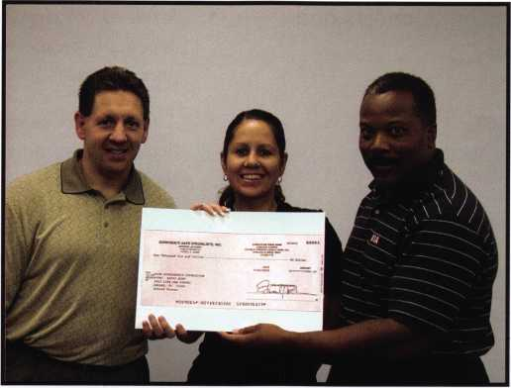

**[www.safe-help.com](http://www.safe-help.com)**

CORPORATE SAFE **SPECIALISTS**

Off ex Ex'pf/rei 12/ / 704

TUe

Hawaiian C/eaP

You gh/e ukgoux nexf~ kafe oxde/t of $*5000*a ox *uoxe and uue kend you and a f/fiend

to f-tavJaii!

**Limited offer for safe resellers only! Call for details.

QOtOI

*/2f/xr/6>* '/sWxr rao  
3uy 3 fax $34- 00

AndOeTf FREE/



Keynotes • October 2004

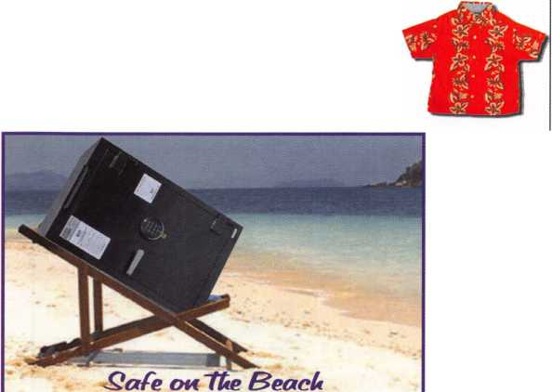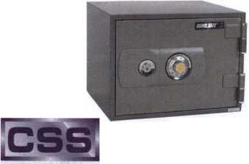

2004 ALOA Scholarship Foundation Sponsors and  
Direct Donations:

:i:YSG

DOOR SECURITY CONSULTANTS

$13,000.00

/to)Security & Safety

V!!fr Prtm Surra. Proven SoiaDocis.

$10,000,000

Corporate Safe Specialists  
$5,000,000

Sargent & Greenleaf

$1,000.00

* A full ALOA convention package, including, depending on individual needs, hotel and trans­portation costs
* A full SAVTA convention package, including, depending on individual needs, hotel and trans­portation costs.
* Sponsored ALOA Certified Class presentations approved by the Foundation Board.
* Other locksmith training provided by education facilities approved by the Foundation Board.

Selection Criteria

The ALOA Scholarship Foundation awards scholar­ships for locksmith education based on several criteria

that includes:

* Individual applicants financial needs

Kaba llco

$500.00

Professional Business Products donates 5% of all sales to the ALOA Scholarship Fund!

Advertise with

Safety Labels!

Lockout your competition by placing your calling card on every door you service! Keep your name in front of every customer with these Durable, Affordable Labels Call & Order Today 1-800-355-6322

**(Actual Label Size** 1 1/2x4 1/2)

Professional Business Products

ALOA Associate Member

BUYING FROM NEBS? We offer lower prices on Invoices, Checks, Business Cards, Repair Tags, Magnets, Key Tags, Pens and Labels. Come see us in Baltimore at the ALOA Security Expo Booth 854

[www.pbp2000.com](http://www.pbp2000.com)

* Character
* Aptitude for the skills necessary in locksmithing
* Demonstration of a desire for a career in lock- smithing
* Availability to attend the event for which the award is given
* Demonstrated commitment to the locksmith industry
* Letters of recommendation from locksmith indus­try references.
* Previous Scholarship awards.

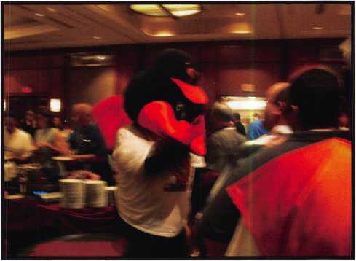

**42**

Keynotes • October 2004



*mm*

Application forms for Scholarships are available from the ALOA web site, in Keynotes magazine, in ALOA booths at local shows and from the ALOA office by request.

Scholarship applications for Safetech or ALOA must be sub­mitted at least 90 days prior to the first day of the event for which the scholarship is being requested. Scholarships for other educational events must be submitted at least 60 days prior to the event being requested, in order to be given ade­quate consideration.

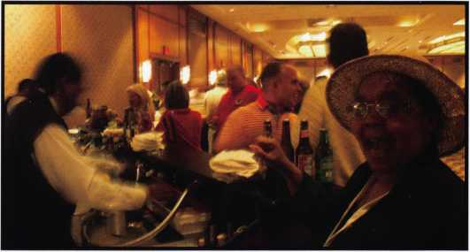

Scholarships are awarded within two weeks of the deadline for submission for each event.

The ALOA Scholarship Foundation Board of Directors awards all scholarships 15 days after the deadline for submission of applications.

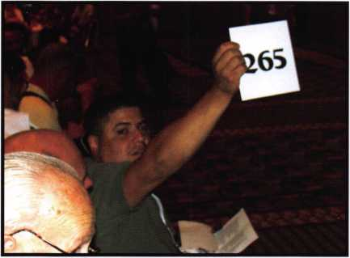

Over $40,000 was raised  
for the ALOA Scholarship  
Foundation at the  
ALOA 2004 Convention  
and Security Expo

New from Adesco. The Latest Technology at Affordable Prices!

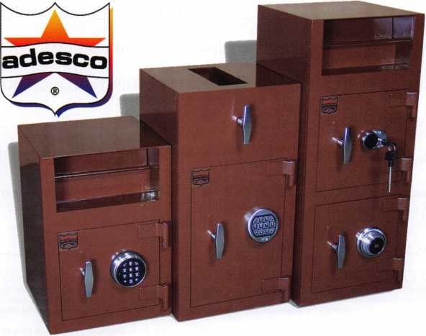

**Special Introductory Pricing and  
Promotions Available Now.**

Introducing the all new Business Deposit Safes from  
Adesco. Safes feature precision plasma cut doors and  
solid 1/2" monoframe faceplates. Door jams are reinforced  
and tied to safe sides. Postal drops offer our famous  
recessed baffle technology. *LaGard's all new Group 2M

combination locks and spy-proof dials included  
at no additional cost. All these features  
and more at an economy price!

Call your Adesco distributor today.

♦When available

(800) 694-9340 • [www.adesco.com](http://www.adesco.com) • [safes@adesco.com](mailto:safes@adesco.com)



Keynotes • October 2004

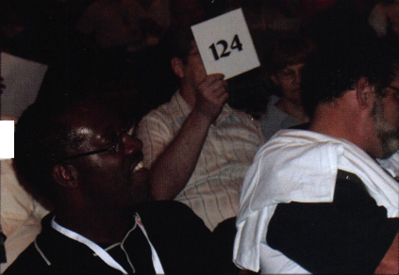

ALOA Scholarship Foundation, Inc.

**An independent, educational, non-profit 501 (C)(3) tax-exempt corporation - Federal Tax ID** # **75-2478220**Headquarters Office • 3003 Live Oak Street • Dallas, Texas 75204-6186 • 214/827-1701 • FAX 214/827-1810

Please print or type

NAME

HOME ADDRESS, HOME PHONE

PRESENT EMPLOYER.

WORK ADDRESS

WORK PHONE

POSITION

SCHOLARSHIP APPLICATION

PRP/STPRP LEVEL

CITY

ALOA/SAVTA#.

.STATE ZIP

. DOB // EDUCATIONAL LEVEL (YEARS) DEGREE, IF ANY_

SUPERVISOR’S FULL NAME

CITY

STATE ZIP

_FAX_

EMAIL:

.FULL TIME PART TIME TAKE HOME PAY.

per

LENGTH OF TIME IN LOCKSMITHING MEMBERSHIP IN TRADE ASSOCIATIONS (List by name)

MARITAL STATUS NUMBER OF DEPENDENTSHOUSEHOLD ANNUAL GROSS INCOME.

CLASSES DESIRED

DATE OF CLASSES.

ORGANIZATION SPONSORING CLASSES: ALOA S A VTA OTHER.

LOCATION

If granted an ALOA Scholarship, will you be able to pay for your own air travel/transportation and hotel accommodations? □ Yes □ No

If no, please explain (use another sheet if necessary):

ALOA Scholarships are granted to selected individuals desirous of entering the locksmithing field or to selected individuals already in the locksinithing field who wish to improve their professional skills through education. The ASF Selection Committee on an objective and nondiscriminatory basis will review applications. The Selection Committee shall hold all materials and information pertaining to the applicant’s financial status and background in strict confidence. Applications for non-convention classes must be received 60 days prior to the date of the non-convention class desired and will be reviewed as they are submitted. Scholarships for classes at the SAVTA or ALOA convention will be awarded each year preceding the convention and must be received 90 days prior to the event requested.

Please include with this form a letter stating: your reason for applying for a scholarship, what you plan to do with the knowledge you obtain and any other information you feel may be helpful to the Scholarship Board in making its decision. In addition, attach three letters of reference from individuals who have personal knowledge of your background and character. The letters should contain their names, addresses and phone numbers. It is helpful if at least one of these references is an ALOA or SAVTA member. All scholarship recipients will be required to provide a 3” x 5” photograph.

APPLICATION CHECKLIST

Only complete applications will be considered for scholarships. An application is considered incomplete unless ALL of the requested information is received before the deadline: 90 days for SAVTA and ALOA convention OR 60 days prior to the non-convention classes. Please send this application after checking off each of the items below. I have filled in each blank on this form.

I have written and enclosed a letter explaining my reason for applying.

I have enclosed three letters of reference.

I am submitting 90 davs prior to the SAVTA or ALOA convention classes OR 60 days prior to the date of another scheduled ACE class or seminar.

I have enclosed a 3” x 5” photograph.

CERTIFICATION OF APPLICANT

I certify that the information contained herem, and all supplemental forms are complete and correct to the best of my knowledge. I further certify that if I am selected as a scholarship recipient I will use the knowledge gained for die improvement, development and advancement of the locksmithing profession. Also, if asked by an authorized ASF official, I agree to give proof of the information that I have given on this application. I also understand that this proof may include copies of my previous year’s Federal Tax Return. I also understand that if no proof is given when requested, I may not receive an ALOA Scholarship Award. I understand that this application is valid only for the event/class specified and is not transferable.

Signature.

Date.

Please send all completed applications to The ALOA Scholarship Foundation at the address at the top of the page.

Revised 07/03

**SAFETY & SECURITY**

Hardware for gates, doors & storage



*Coming your way - a wave of innovation from D&D*



***'ll***

m

The Ultimate  
Security Gate Latch

lrtch® PRO is the most sophisticated cy and security gate latch ever devised. It is rivacy latch that locksmiths and security lesses have been raving about!

quality, patented latch can be rated and locked from either of the gate!

•Latch PRO is uniquely constructed to work tively in both residential and commercial applications. The "External Push-Button s" component fits to the outside (street side) e gate post to provide convenient, key- ble access.

is a standard 6-pin key-in-knob style lock fer. This cylinder can be keyed-alike, in-keyed and master-keyed, or can be ced with a higher security cylinder.

**MAGNETIC SAFETY GATE LATCH**

Why take chances when choosing a child safety gate latch? MAGNA*LATCH® provides magnetic safety unmatched by any other gate latch.

The patented magnetic technology means this latch incurs **no mechanical resistance to closure,** meaning it will work smoothly and reliably over time.

MAGNA*LATCH is easy to install (externally) to new or existing gate and fence materials. It is fully adjustable both vertically and horizontally.

dbd frEEhnnlcqiEs

**Safety, Privacy & Security**

i

Quality

Endorsed

Company

The Security  
Lock with Style

The Forte™ "Hasplock" introduces a new standard in quality commercial and industrial locking security.

Forte HaspLocks (4 models) are designed for all types of storefront, door, gate and storage locking, either as add-on security for existing locks or as primary locks.

Made from 316-grade stainless steel, the Forte Hasplock is ideal for use in marine or other corrosion-prone environments.

Quality Forte Hasplock is highly resistant to hacksawing, levering and oxyacetylene cutting.

Gate Security - no

D&D Technologies (USA) Inc., 7731 Woodwind Drive, Huntington Beach CA 92647  
Tel: (800) 716-0888 ext. 231 Fax: (800) 464-6400 E-mail: [gateware@ddtechusa.com](mailto:gateware@ddtechusa.com)

**See our product range**

**[www.ddtechusa.com](http://www.ddtechusa.com)**

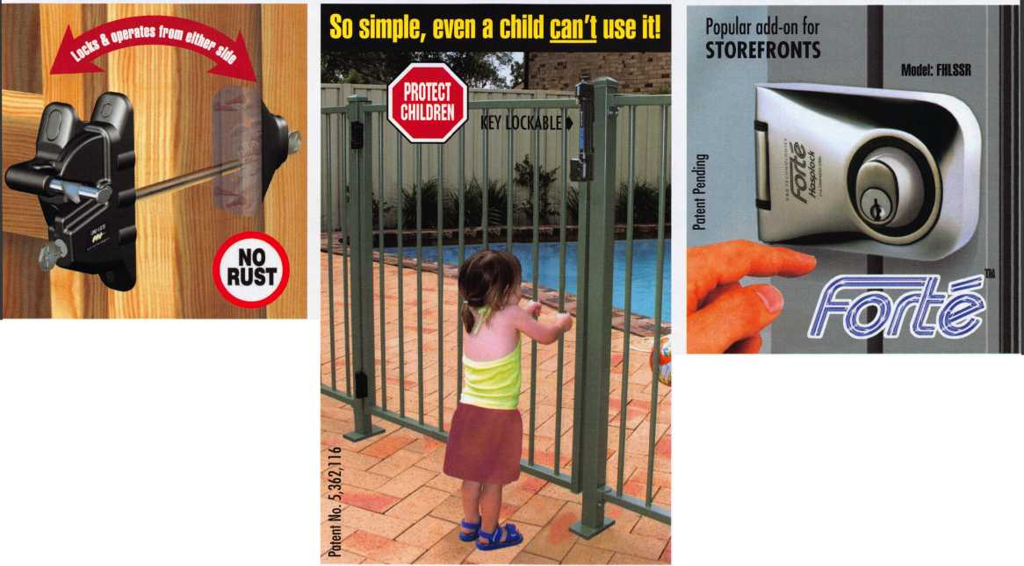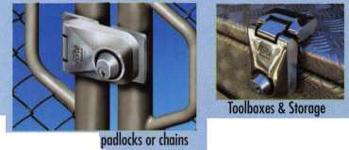

**ISI o.wiCmN**

|  |  |  |
| --- | --- | --- |
| Wj¥ | p | iet< |
| -M( | ?r | cui |
| i trc | in | spi |
| m | Pi | ete |
| / | V N 1 |

